Welcome to the latest
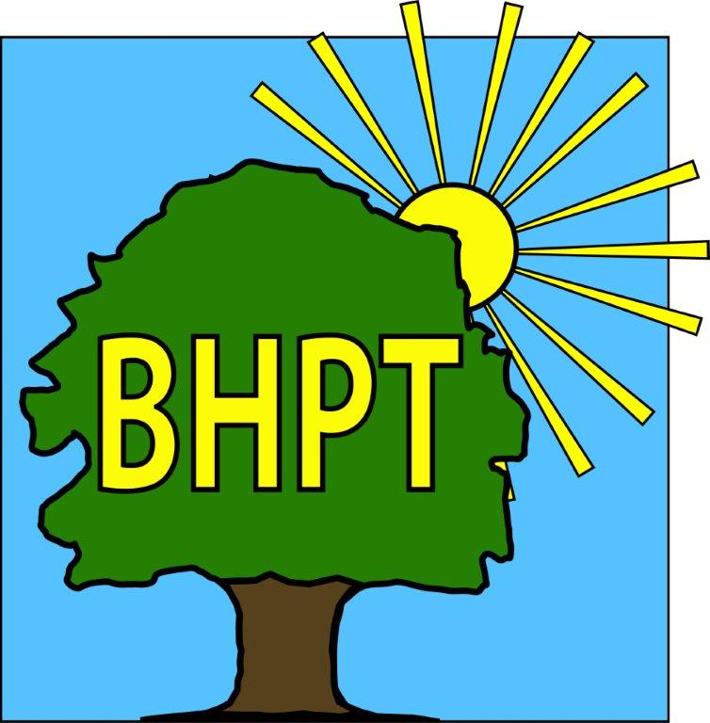
BHPT Newsletter
September 2022

Get moving!
We are pleased to work with some great local providers who are eager to get us moving in a safe and caring environment.
- Seated Exercise with Donna is on Mondays. It is suitable for those over 60 and is on from 9.45am-10.45am at Burnham Methodist Church, it is £5 per session.
- Tai Chi with Colin Bond is also on Mondays at Burnham Park Hall, from 2-3pm. It is suitable for adults of all abilities and costs £5 per session of 4 for £15.
- Outdoor Gym group is on Tuesday 10.30am-11.30am at Burnham Park Green Gym. It’s free to attend and for adults of any age.
- Walking Football is on Wednesday, run by GLL in Burnham Park from 10am-11am. Its £3 a session.
- Simply Walk has various walks on different day in the local area, for different abilities. See our timetable for more information.

For more information, such as contact details, on all of these initiatives please do look on our website for our timetable.

Hello Everyone,
We hope you are all ok after such warm weather. We wanted to tell you about the fitness groups we support locally and also what help is available with the electricity & gas price increases. We will also share with you our usual Care & Share update and information on one of our new groups, Hormones & Happiness.

As always, we are continually updating our website to bring you the most up to date and useful information. Please register for updates and also to view our timetable of activities along with other information on useful local services. Our Facebook group also has details of forthcoming events, news and information. We also share posts on local groups so you wont miss out on local events.

If you require assistance, especially with food vouchers contact Lisa (07852 509075) or Rev Samson (07771728826) or you would like to speak to us please ring our office number on 01628 661441. Do leave a message if the answer machine is on, we might be on another call, but we will get back to you

Look after yourselves and each other.

Dawn Harries, Chief Officer and the staff and Trustees of Burnham Health Promotion Trust

Care & Share
August usually sees a drop in numbers although figures this year are the highest August statistics we've had since opening our doors! We are already seeing an increase in September's figures, so welcome any support in the form of food or monetary donations.
Total figures for July & August were: 411 people in total receiving support over the 2 months, of which 200 were children and new statistics we are now recording, 20 over 65-year-olds seeking support in August!

As usual, our collection points are (subject to opening times):
Burnham Park Hall - Reception
Cornerstone St Peters - Main office/collection boxes
Burnham Library - Village Information Point collection box
Old 5 Bells Pub - Bar staff

If you would like to donate items but are unsure of what to purchase, you can look at our Facebook page for the pinned post of food bag items, or feel free to contact BHPT on 01628-661441 for suggestions. We also welcome financial donations via the link on our website www.bhpt.org.uk

As always, thank you to all our volunteers, supporters & donors (many of whom wish to remain anonymous) We are so grateful for your help.

The Care & Share Team

Energy Advice
This is a topic very much affecting many people right now and will certainly do in the coming months. We have put together many of the things you might need to know from the government grants available (for every household) to what help is available.
Visit our blog post at www.bhpt.org.uk/news/help-with-utilities if you do not have access to the internet and would like advice, please come in or phone us.
If you know of anywhere else where help is available let us know and we can update our website to help others.

Hormones & Happiness
This is our newest project to support women in the Peri-menopause or Menopause.
This group is for you if…you are confused about the menopause, you are not sure if the symptoms you are experiencing are the menopause, want to learn wellness tools so you can thrive & not just survive this transition, would like to future proof your brain, bones & heart, you would love to feel supported with a like minded group of women. For more information on dates, fee & how to book your place, please contact Lisa on lisa@bhpt.org.uk or 07852 509075.

our contact information
Burnham Health Promotion Trust, Burnham Health Centre, Minniecroft Road, Burnham, Bucks, SL1 7DE
01628 661441 - info@bhpt.org.uk - www.bhpt.org.uk

