Welcome to the latest
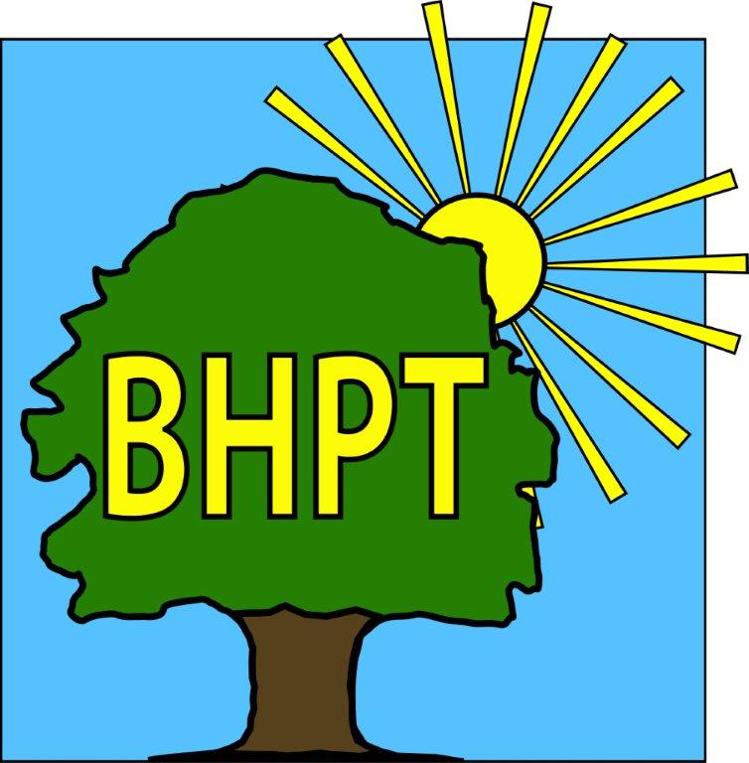
BHPT Newsletter
September 2023

Citizens Advice
Our Citizens Advice advisor comes to Burnham Park Hall on Wednesday mornings. Citizens Advice can help with a variety of issues, such as benefits forms & appeals, housing problems, legal enquiries and more. To book an appointment call 01494 791391. There may also be the option of a telephone appointment.
The Well at Lent Rise also offer a Drop - In option on the 2nd Wednesday of the month, every month from 9am - 12pm. The Well meet at Burnham Methodist Church, 87 Lent Rise Road, Burnham, SL1 7NZ. This service is on a 1st come basis.

Job Club
If you are over 18 and looking for work or to change jobs, and would like some support with CV’s, applications, cover letters, interview tips and moral support while job hunting then come and see us. It’s a free, weekly meeting at Burnham Library, Tuesday 12-2pm just drop in. Please call or email Gemma on 07483 326525 gemma@bhpt.org.uk if you have any questions. We have had some successes already, sometimes all you need is an updated CV.

Hello to our readers!
The BHPT staff are in the office and ready to help with your enquires. We have a few updates for you today.

As always, we are continually updating our website to bring you the most up to date and useful information. Please register for updates and also to view our timetable of activities along with other information on useful local services. Our Facebook group also has details of forthcoming events, news and information. We also share posts on local groups so you wont miss out on local events.

If you require assistance, especially with food vouchers contact Lisa (07852 509075) or Rev Samson (07771728826) or you would like to speak to us please ring our office number on 01628 661441. Do leave a message if the answer machine is on, we might be on another call, but we will get back to you

Dawn Harries, Chief Officer and the staff and Trustees of Burnham Health Promotion Trust

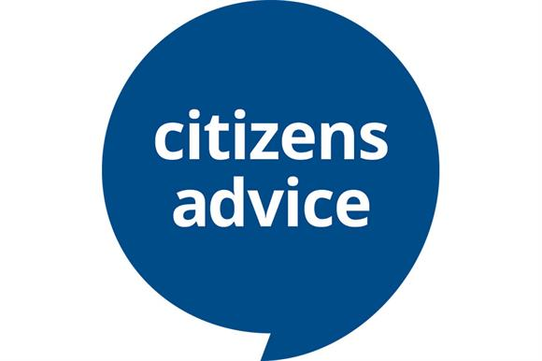
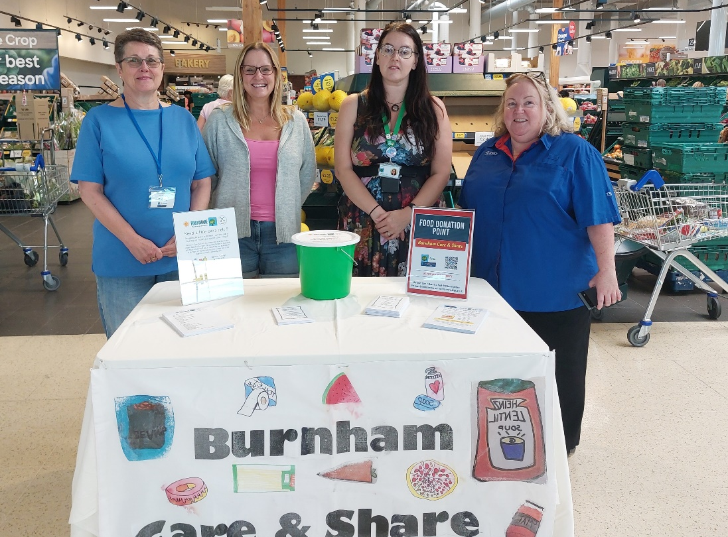

Picture:
Staff & Volunteers at the Tesco Food Drive for Care & Share! A successful day
Keeping Fit
If you are looking for ways to up your weekly exercise, look no more!
Seated exercise with Donna (lower impact for 50+)
Simply Walk (a walking group with all ability walks)
Walking Football (over 50 males and ladies of any age)
Tai Chi with Colin Bond (all abilities)
For more information on these classes, such as days, times & costs, please visit our website.

Care & Share
On Friday 25th August Care & Share staff partnered with Tesco Taplow to run a Food Drive for the foodbank.
Over 4 hours, staff stood at the front of the store in The Bishops Centre and handed out shopping lists of items that we stock regularly to customers. We asked, if they were able, to purchase an item on the list and hand to our staff before leaving the shop. Tesco customers came up trumps and we collected 22 large crates of food!! An Amazing amount!! Thank you to Petra, Community Champion at Tesco for helping to organise this for us, to the Care & Share staff who gave up their Saturday to help collect, transport and date mark all food and of course to the Tesco Customers for supporting us! We really do appreciate your help!

We are now collecting donations towards our Christmas Tombola at the Burnham Lights Parade in early December. If you have any unopened, unused toiletries, gift packs or childrens toys you would like to donate to our fundraising effort, please drop them into Burnham Park Hall reception for our attention. All money raised from the tombola goes directly to Care & Share, helping support those in need in our community.

If you would like to donate food items to Care & Share, you can drop your donation to any of the following collection points:
Burnham Park Hall Reception Monday to Friday 9.00am-5.00pm
Burnham Library VIP area, Tuesday to Saturday during standard opening hours
Cornerstone St Peters Church, 9.30am-12.00pm Mon-Fri.
Care & Share direct, Every Tuesday & Friday at Burnham Park Hall between 2.00pm and 4pm.
We can also take online donations on our website’s homepage.

If you are in need of support, please contact your local school if you have school age children, Cornerstone at St Peter's Church or Burnham Health Promotion Trust to ask about vouchers for the foodbank.

Lisa Pope, Care & Share Co-Ordinator 07852-509075
our contact information
Burnham Health Promotion Trust, First Floor, Burnham Park Hall, Windsor Lane, Burnham, Bucks, SL1 7HR
01628 661441 - info@bhpt.org.uk - www.bhpt.org.uk

