Welcome to the latest
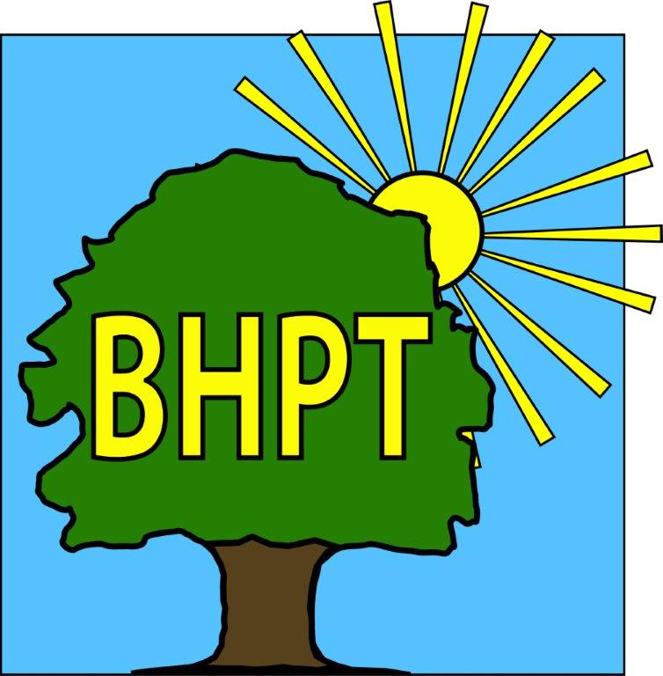
BHPT Newsletter
November 2022

Hello Everyone,
We hope you are enjoying the beautiful colours of the changing season and are looking forward to the festive season. In this edition we wanted to tell you about the Council Access Point in the Library and give our usual Care & Share update. We also wanted to remind everyone that we will be attending the Lions Festive Fayre on December 1st. Come and visit us at our popular bottle and gift tombola stall, all proceeds go to Burnham Care & Share.

As always, we are continually updating our website to bring you the most up to date and useful information. Please register for updates and to view our timetable of activities along with other information on useful local services. Our Facebook group also has details of forthcoming events, news and information and we share posts on other local groups so you won’t miss out on local events.

If you require assistance, especially with food vouchers contact Lisa (07852 509075) or Rev Samson (07771728826) If you would like to speak to us please ring our office number on 01628 661441. Do leave a message if the answer machine is on, we might be on another call, but we will get back to you.

Look after yourselves and each other.

Dawn Harries, Chief Officer and the staff and Trustees of Burnham Health Promotion Trust

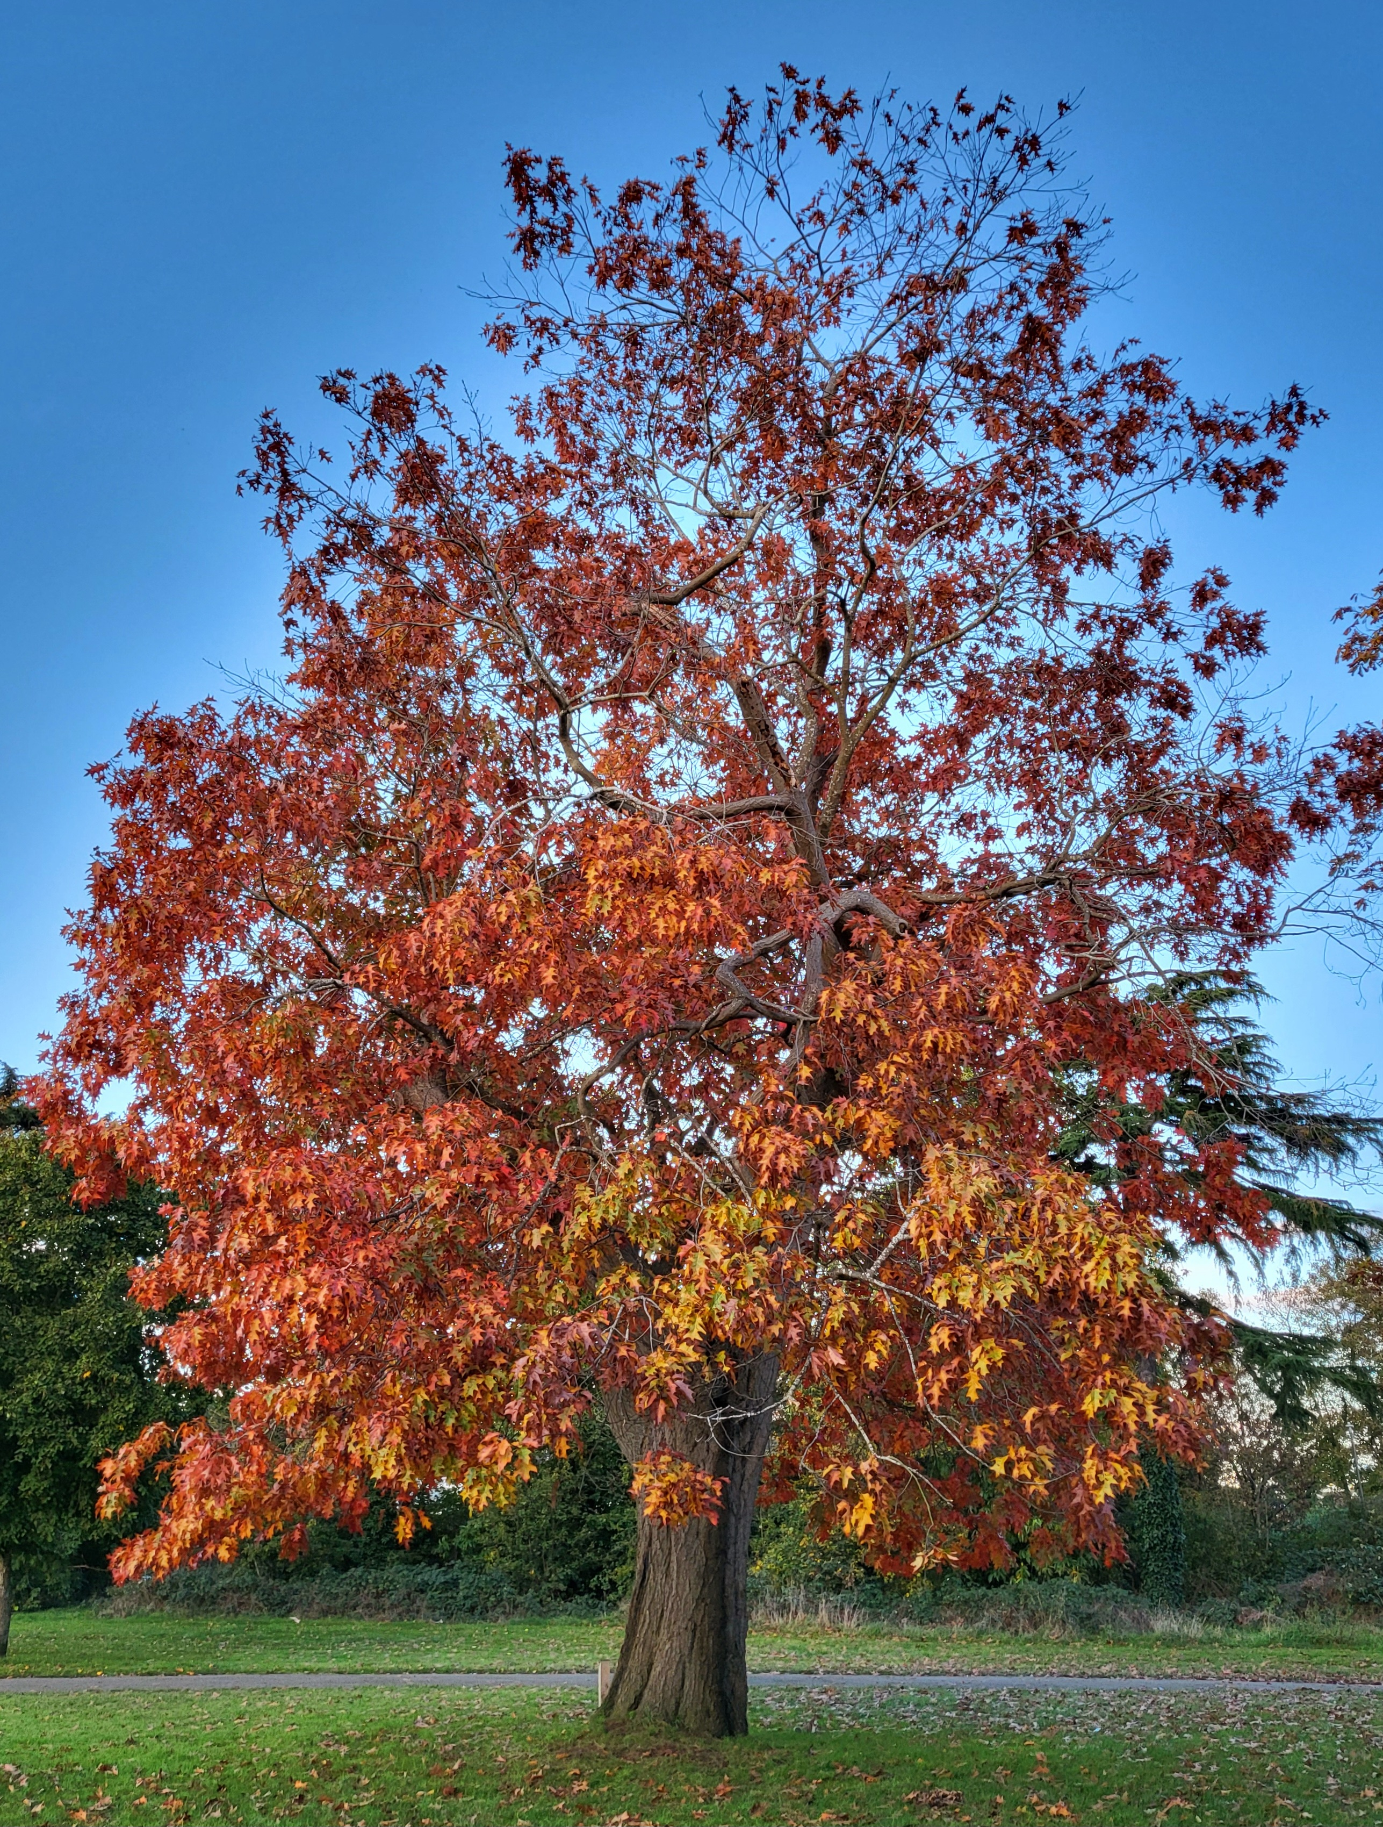

We have successfully completed the pilot of the Menopause support group, Hormones and Happiness and would like to thank all the ladies who assisted us in this. We are now accepting new members for the rollout of the main project in January 2023, so if you are struggling with Perimenopause or Menopause symptoms and would like to learn how you can support yourself through this time in your life, please email Lisa@bhpt.org.uk for more information or log onto Julie Hall's website www.wellbeingboutique.co.uk to book your place.

Energy Advice

Visit our blog post at www.bhpt.org.uk/news/help-with-utilities which contains details of government grants and other help available. If you do not have access to the internet and would like advice, please come in or phone us. If you know of anywhere else help is available let us know and we can update our website to help others.

Care & Share
In the run up to Christmas, we are already seeing our numbers start to rise, so the need for more food donations is imperative. Working with Bucks CC & The Street Association, we have launched Burnhams Food Champions scheme, where you can become your streets food collector on behalf of Care & Share. Please contact Lisa@bhpt.org.uk for your support information pack on how to become a Food Champion.
Care & Share will have a gift & bottle tombola stall at this year's Burnham Lions Christmas light parade on Dec 1st. Last year we sold out in just over an hour, so don't leave it too late to come and find us. All profits to Care & Share.

If you would like to donate items but are unsure of what to purchase, you can look at our Facebook page for the pinned post of food bag items, or feel free to contact BHPT on 01628-661441 for suggestions. We also welcome financial donations via the link on our website www.bhpt.org.uk

As always, thank you to all our volunteers, supporters & donors (many of whom wish to remain anonymous) We are so grateful for your help.
The Care & Share Team

Council Access Point
At Burnham Library there is a ‘Council Access Point’ - a way to get in contact with a range of council departments without using your phone credit or a payphone. Their trained staff are on hand to help with common queries, such as reporting a pothole or ordering a replacement bin.
We know that there can be longer than usual waiting times when trying to get through on the telephone and the council and library are trying to make it easier for residents. You can pull up a chair, make notes if you need to and not worry about the phone bill.
The Access Point is located just to the right of the main door. You can also use the self service computers to access services online or use the phones to speak to a member of staff.
If you would like to volunteer at the library or sign up to take out books, just ask the friendly staff at the counter.

our contact information
Burnham Health Promotion Trust, Burnham Health Centre, Minniecroft Road, Burnham, Bucks, SL1 7DE
01628 661441 - info@bhpt.org.uk - www.bhpt.org.uk

