Welcome to the latest
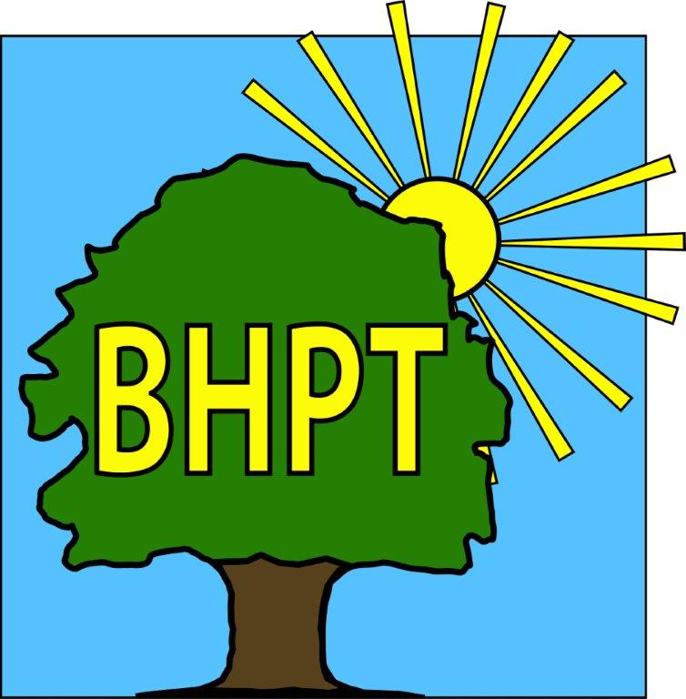
BHPT Newsletter
November 2023

Hello to all of the Round & About readers as we look forward to Christmas! We look forward to seeing you at the Christmas Fayre on 7th December.
In this edition we wanted to tell you about help that is available for the coming months and remind you about some of our services.

We are continually updating our website to bring you up to date and useful information. Please visit to view our timetable of activities, along with our Facebook group for details of forthcoming events, news and information.

If you require assistance, especially with food vouchers contact Lisa on 07852 509075 or the office on 01628 661441. Do leave a message if the answer machine is on, we might be on another call, but we will get back to you.

Look after yourselves and each other.

Dawn Harries, Chief Officer and the staff and Trustees of Burnham Health Promotion Trust

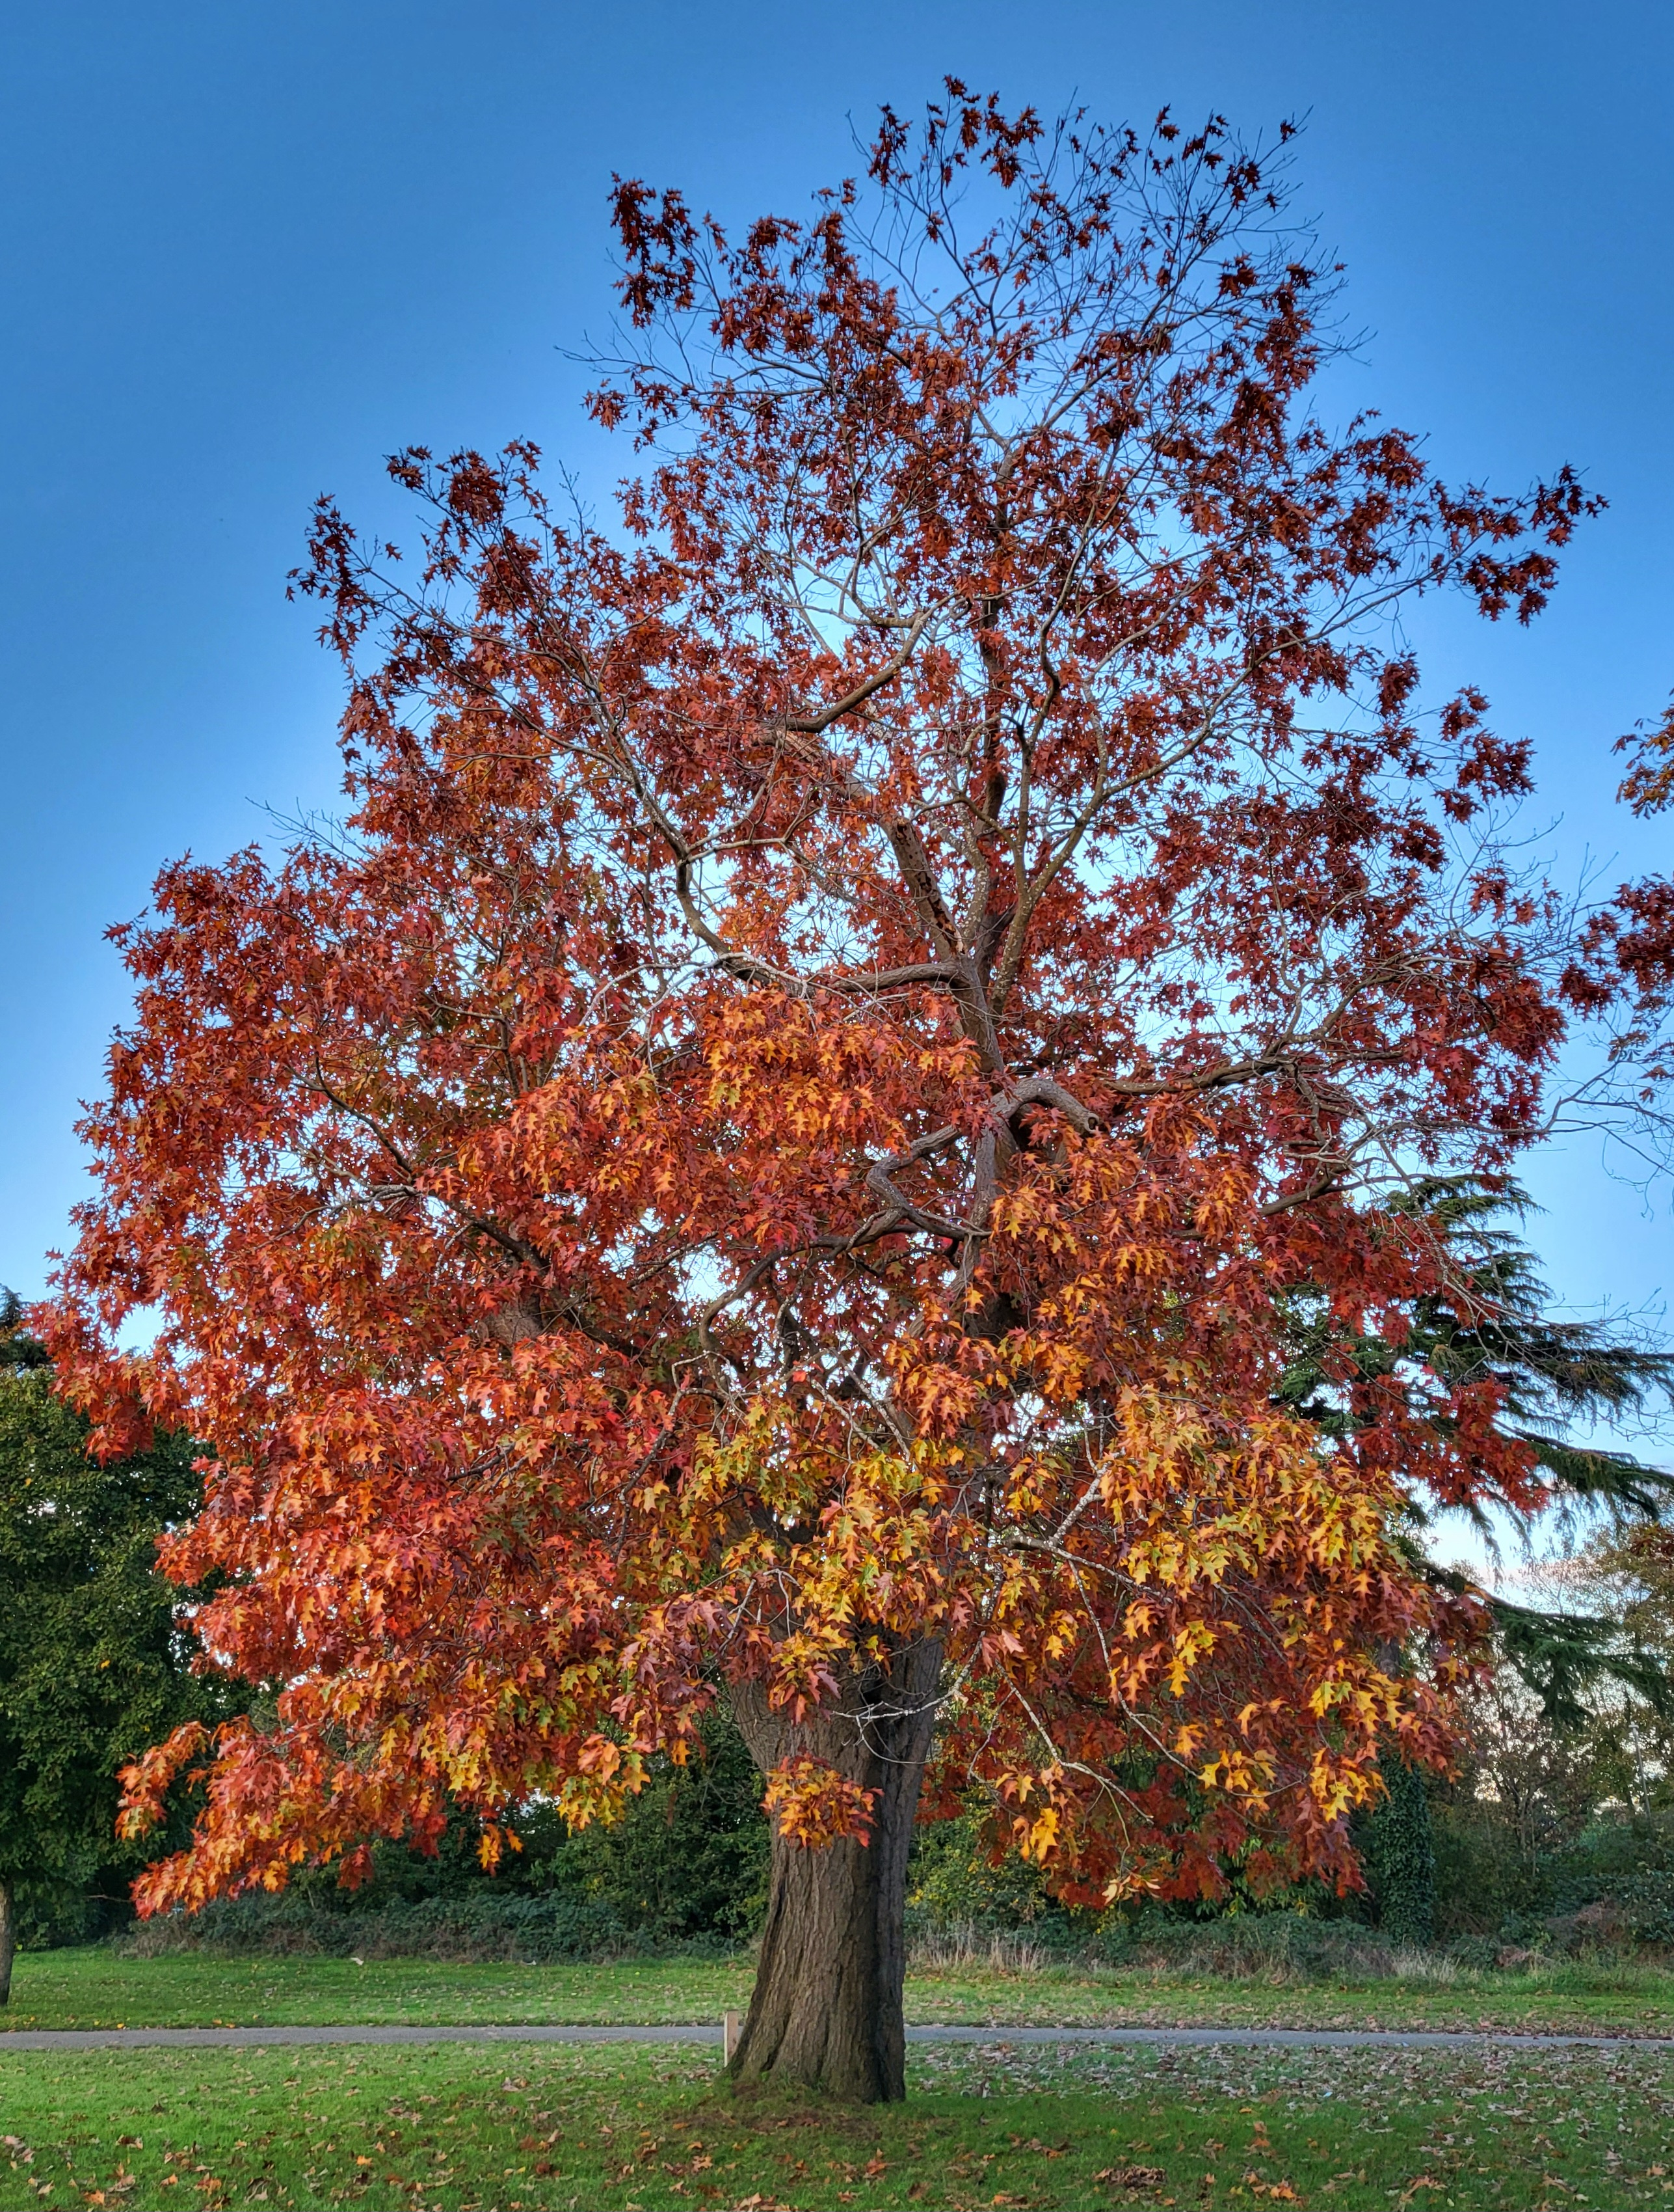
Keeping Warm
There are Warm Spaces locally if you are looking to spend time out of your house this winter to keep utilities costs down. Burnham Park Hall and Burnham Library are open for the longest times, they have comfortable seating, jigsaws/games available and wifi facilities. St Peters Church offer a Wednesday Welcome from 10-12noon also.
We have also put together a useful information post on our website about what help is available with utilities. If you don’t have access to the internet and would like to know more about this, or any information about the Warm Spaces (such as opening times) you can call or come in to the office. www.bhpt.org.uk/news/help-with-utilities/

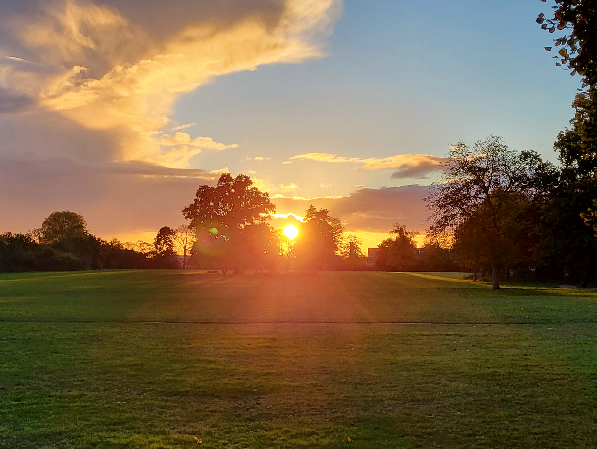

Citizens Advice
Our Citizens Advice advisor comes to Burnham Park Hall on Wednesday mornings. Citizens Advice can help with a variety of issues, such as benefits forms & appeals, housing problems, legal enquiries and more. To book an appointment call 01494 791391. There may also be the option of a telephone appointment. Please do leave a message, they will call you back if all the advisors are busy.
The Well at Lent Rise also offer a Drop - In option on the 2nd Wednesday of the month, every month from 9am - 12pm. The Well meet at Burnham Methodist Church, 87 Lent Rise Road, Burnham, SL1 7NZ. This service is on a 1st come basis.

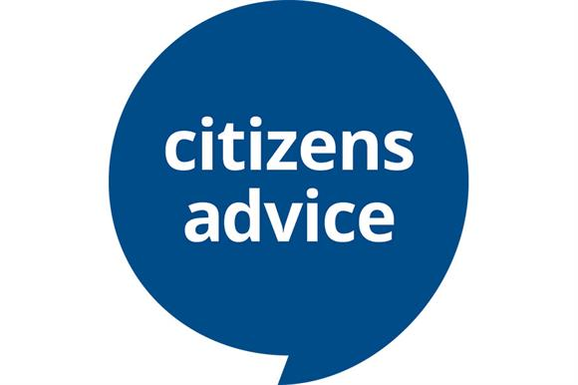

Care & Share
There is still time to donate towards our Christmas Tombola at the Burnham Lights Parade next week! If you have any bottles of wines or spirits, unopened/ unused toiletries, gift packs or good condition childrens toys you would like to donate to our fundraising effort, please drop them into Burnham Park Hall reception for our attention. All money raised from the tombola goes directly to Care & Share, helping support those in need in our community.

If you would like to donate food items to Care & Share, you can drop your donation to any of the following collection points:
Burnham Park Hall Reception Monday to Friday 9.00am-5.00pm
Burnham Library VIP area, Tuesday to Saturday during standard opening hours
Cornerstone St Peters Church, 9.30am-12.00pm Mon-Fri.
Care & Share direct, Every Tuesday & Friday at Burnham Park Hall between 2.00pm and 4pm.
We can also take online donations on our website’s homepage.

If you are in need of support, please contact your local school if you have school age children, Cornerstone at St Peter's Church or Burnham Health Promotion Trust to ask about vouchers for the foodbank.

Lisa Pope, Care & Share Co-Ordinator 07852-509075

Burnham Library
We work closely with Burnham Library and wanted to mention a few things here on their behalf. Have you visited them recently? They just celebrated their 50th year and we were lucky enough to join in with a big singing-celebration! We had a Singing For Your Memory coffee morning on 3rd October, which included music from the 70’s, cake and fancy dress.
The children’s area has had a fabulous makeover, thanks to funds raised by The Friends Of Burnham Library, it has its own special entrance arch. The library really is a welcoming space for people of all ages.
Don’t forget you can access computers, the local council telephone point, we hold our Job Club there Tuesday 12-2pm and they are a Warm Space for the coming winter.

our contact information
Burnham Health Promotion Trust, First Floor, Burnham Park Hall, Windsor Lane, Burnham, Bucks, SL1 7HR
01628 661441 - info@bhpt.org.uk - www.bhpt.org.uk

