Welcome to the latest
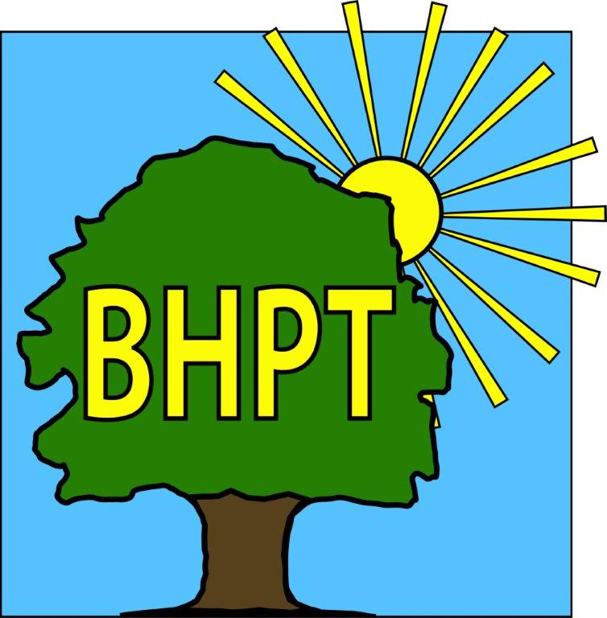
BHPT Newsletter
Apr / May 2022

Hello to all of the Round & About readers!
It’s lovely to see so many of you on our travels around the village.
In this edition we wanted to let you know about our next Wellbeing Day, the events we will be attending, the Citizens Advice service here in Burnham, our Job Club and the usual Care & Share update.

We are continually updating our website to bring you up to date and useful information. Please visit to view our timetable of activities, along with our Facebook group for details of forthcoming events, news and information.
We hope to see you at one of the local events we are attending soon, the Hitcham & Taplow Society Village Green Party and the Donkey Derby. We talk more about these below.

If you require assistance, especially with food vouchers contact Lisa on 07852 509075 or the office on 01628 661441. Do leave a message if the answer machine is on, we might be on another call, but we will get back to you.

Look after yourselves and each other.

Dawn Harries, Chief Officer and the staff and Trustees of Burnham Health Promotion Trust

Job Vacancies
BHPT currently have two employment vacancies, both based at Burnham Park Hall;
- Part time Clerk to the Trustees & Administrative Assistant, 12 hrs per week - Contact dawn@bhpt.org.uk
- Part time Duty Manager for Care & Share, 6hrs per week - Contact lisa@bhpt.org.uk
Applicants will be subject to a full DBS & Reference check. Closing date for both roles, Friday 30th June 2023. For more information call the BHPT Office 01628-661441

Citizens Advice
We are pleased to say that our Citizens Advice advisor now comes to Burnham Park Hall every Wednesday morning. Citizens Advice can help with a variety of issues, such as benefits forms & appeals, housing problems, legal enquiries and much more. To book an appointment please call 01494 791391. There may also be the option of a telephone appointment.

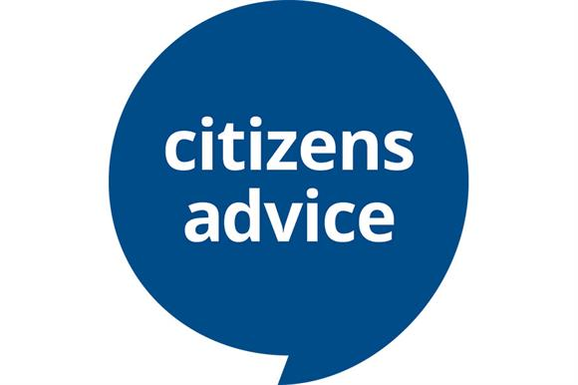

Ladies Wellbeing Day
After the success of our first Ladies Wellbeing Afternoon in January, we are delighted to announce our 2nd event on Sunday 4th June 2.15pm-5.30pm at Burnham Park Hall. Tickets cost £8 per person.
As well as meeting local small businesses offering support and selling their products in the Dropmore Hall, attendees will be able to sign up for a free taster session of beauty / complimentary therapy treatments in the Huntercombe Room Hall, receive a free welcome drink and the first 40 ladies through the door will receive a free goody bag.
Tickets can be purchased on Eventbrite https://www.eventbrite.co.uk/e/ladies-wellbeing-afternoon-tickets-626112468247


Care & Share
Care & Share will be holding a Bottle & Gift tombola stall at this years Donkey Derby on Saturday 27th May. Donations of wine, spirits, fizz and new unused toiletries & gift sets welcomed, drop off at BHPT at Burnham Park Hall (First Floor).
This year, Care & Share have also been invited to host the raffle table at the Hitcham & Taplow Society Village Green Party, in Taplow on Saturday June 24th. Prizes include tickets to local venues, meals out and goodies including Champagne, Gin and Cadburys Chocolate Hampers. Tickets on sale soon - check social media pages for info.

BHPT are seeking a part-time duty manager and admin support for Care & Share. The role is for 6 hours a week and is based at Burnham Park Hall. Please email lisa@bhpt.org.uk for more information and a job description. Closing date 31st May 2023.

Lisa Pope and Rev. Samson Kuponiyi

Job Club
BHPT have started a job club! If you are over 18 and looking for work or to change jobs, and would like some support with CV’s, applications, cover letters, interview tips and more, then come and see us. It’s a free, weekly meeting at Burnham Library, Tuesday 12-2pm just drop in. Please call or email Gemma on 07483 326525 gemma@bhpt.org.uk if you have any questions.

our contact information
Burnham Health Promotion Trust, First Floor, Burnham Park Hall, Windsor Lane, Burnham, Bucks, SL1 7HR
01628 661441 - info@bhpt.org.uk - www.bhpt.org.uk

