Welcome to the latest
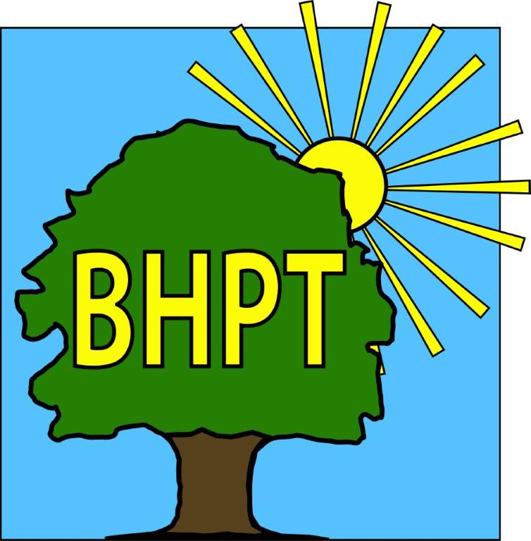
BHPT Newsletter
March 2023

It’s lovely to see the flowers blooming around the village. We are looking forward to getting out on more walks and seeing you on our travels.
In this edition we wanted to let you know how our Wellbeing Afternoon went, update you on Care & Share and talk about a few of our initiatives Singing For Your Memory, Job Club & Food Champions.

We are continually updating our website to bring you up to date and useful information. Please visit to view our timetable of activities along with other information on useful local services. Our Facebook group also has details of forthcoming events, news and information. We also share posts on local groups so you wont miss out on local events. With energy prices being so important right now, we have put together a useful post on many of the things you might need to know, from the government grants (for every household) to what other help may be available. Visit our blog post at www.bhpt.org.uk/news/help-with-utilities if you do not have access to the internet and would like advice, please come in or phone us.

If you require assistance, especially with food vouchers contact Lisa 07852 509075 or Rev Samson 07771728826 or you would like to speak to us please ring our office number on 01628 661441. Do leave a message if the answer machine is on, we might be on another call, but we will get back to you

Look after yourselves and each other.

Dawn Harries, Chief Officer and the staff and Trustees of Burnham Health Promotion Trust


Hormones & Happiness Ladies Well-being Afternoon
Sunday the 29th January was the date of our first big Wellbeing day at Burnham Park Hall. We welcomed 70 ladies on the day who were able to choose a free taster 20 min treatment from local therapists, such as Indian head massage & reflexology in the Huntercombe Hall treatment room. In the Dropmore hall, we had local people promoting exercise, beauty, healthy food and wellbeing products. Ladies were also treated to a free welcome drink from the bar. Overall, the feedback was excellent, and we intend to hold another Wellbeing day in the summer, so look out for adverts nearer the time. Thank you to everyone who attended and supported the event.
For more information and pictures see our website.

Job Club
BHPT have started a job club! If you are over 18 and looking for work or to change jobs, and would like some support with CV’s, applications, cover letters, interview tips and more, then this might be the group for you! It’s a free, weekly meeting at Burnham Library, Tuesday 12-2pm just drop in. Please call or email Gemma on 07483 326525 gemma@bhpt.org.uk if you have any questions.

Food Champions
Care & Share has been involved in a pilot group for Bucks CC and the Street Association, by enlisting Food Champions in the Burnham area. Local people are invited to become their streets Food Champion which involves collecting long-life food products & household items from their neighbours on a once-a-month basis. They will then deliver this collection to Care & Share on an agreed date. It's a simple and easy way to get involved in the community, so if you are interested in becoming your streets champion, please email Lisa at lisa@bhpt.org.uk for more information.
Care & Share
We remain busy with new people reaching out for support all the time. Clients come & go at food banks, as & when their circumstances change, but we are happy to continue on-going support alongside people like Helping Hands at Bucks CC who assess clients for additional support and benefits. Helping Hands have recently awarded Care & Share a substantial grant which will help us through into the summertime. Please do continue supporting us with your donations though as this is what keeps us ticking over. A donations list can be found on the BHPT website along with a list of collection points in the village.

Lisa Pope and Rev. Samson Kuponiyi


our contact information
Burnham Health Promotion Trust, First Floor, Burnham Park Hall, Windsor Lane, Burnham, Bucks, SL1 7HR
01628 661441 - info@bhpt.org.uk - www.bhpt.org.uk

