Welcome to the latest
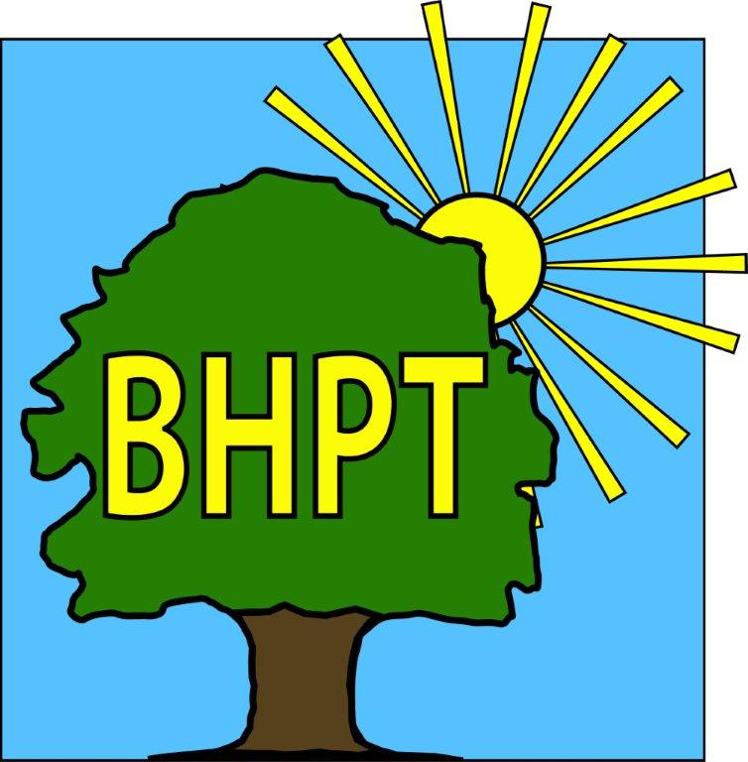
BHPT Newsletter
July 2023

Hello to all of the Round & About readers!
We hope you have been enjoying the sunshine recently. It was lovely to see so many of you at the Village Fete.
In this edition we wanted to remind you about our regular initiatives such as Job Club, Citizens Advice and Care & Share, along with a couple of extra things we have been up to since the last issue.

We are continually updating our website to bring you up to date and useful information. Please visit to view our timetable of activities, along with our Facebook group for details of forthcoming events, news and information.

If you require assistance, especially with food vouchers contact Lisa on 07852 509075 or the office on 01628 661441. Do leave a message if the answer machine is on, we might be on another call, but we will get back to you.

Look after yourselves and each other.

Dawn Harries, Chief Officer and the staff and Trustees of Burnham Health Promotion Trust

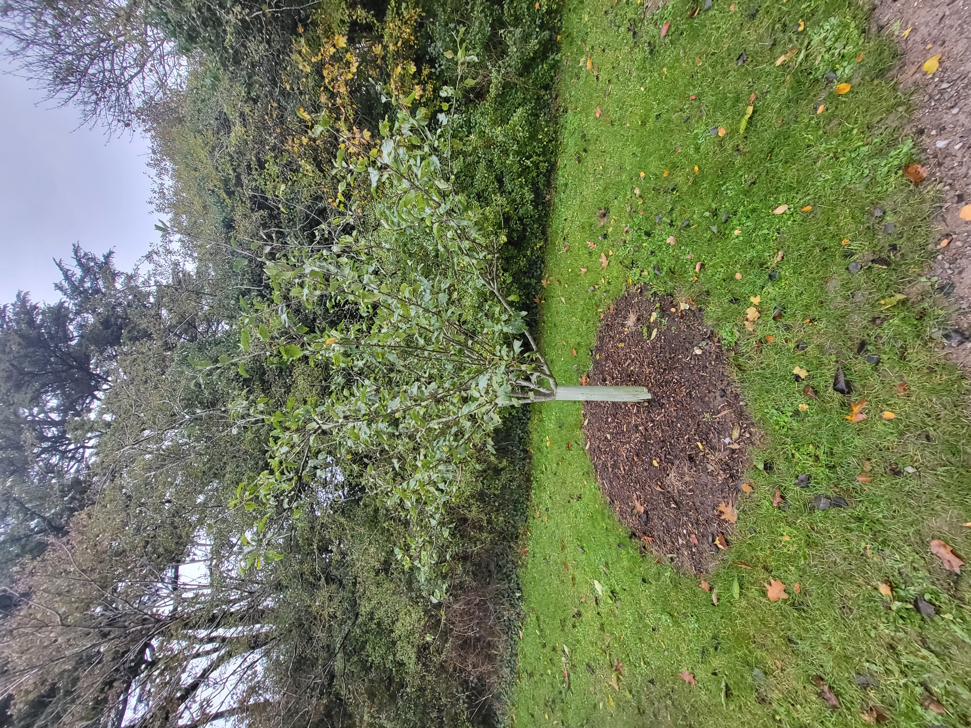
Life Saving Advice!
BHPT recently funded some First Aid courses run by local company, Face2Face Medical. 38 local people involved in groups such as Care & Share, Simply Walk, Men's Shed, Rotary Club, BCA and St Peter's Church took part and received up to date training on Adult Basic Life Support including choking & anaphylaxis and took part in demo's of Automated External Defibrillators sessions. We hope to be arranging more courses for local people and are considering Paediatric life support for those with small children and Older Paediatric sessions for child group leaders, i.e. Scouts, Youth Club etc. If you are interested in taking part in either of these, or Adult Basic Life Support, please email lisa@bhpt.org.uk to register your interest.
With Defibrillators in mind, do you know where the nearest machines are to you? Here is a current list within the local area.
Burnham Park Hall -SL1 7HR
Burnham Medical Centre-SL1 7DE
Esso Petrol Station, Lent Rise Road-SL1 7BH
Lent Rise School-SL1 7NP (School opening times only)
Haybrook College, Burnham Lane-SL1 6LZ
George Pitcher Memorial Ground-SL1 8DL
Terry Eames Fire & Security, Nursery Road-SL6 0JU
Pure Gym, Buckingham Ave-SL1 4JB
Tesco Express, Burnham Lane-SL1 6LE
Royal Toxophilite Society, Dropmore Road-SL1 8NB
Oak & Saw Pub, Taplow-SL6 0ET


Ladies Wellbeing Day
Following the postponement of our summer Ladies Wellbeing day, we are pleased to announce that it has been rescheduled to Sunday the 17th September 2023. Tickets are just £8 each and include a free welcome drink, a free 20 min taster session of complimentary therapy/sports massage and the first 40 ladies through the door will receive a free goody bag worth £15. To book your tickets go to https://www.eventbrite.co.uk/e/646367912827
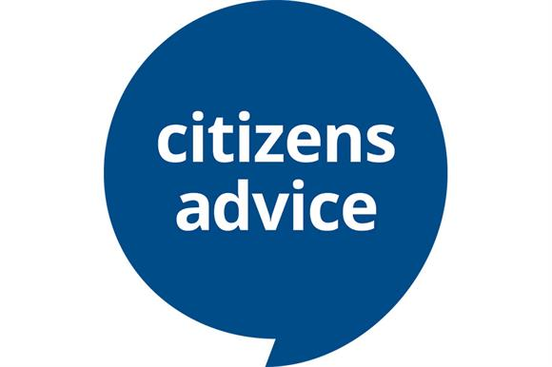
Citizens Advice
Our Citizens Advice advisor comes to Burnham Park Hall every Wednesday morning. Citizens Advice can help with a variety of issues, such as benefits forms & appeals, housing problems, legal enquiries and much more. To book an appointment please call 01494 791391. There may also be the option of a telephone appointment.

Care & Share
Burnhahm Care & Share were recently invited to host the raffle table at the annual Hitcham & Taplow Society Village Green Party on Saturday 24th June. We were sponsored by many local companies including Taplow House Hotel, Odds Farm, Artigiani del Cibo Restaurant, Woodstock's Coffee Shop, Bekonscot Model Village, The Oak & Saw Pub and many local people who all donated prizes. We raised over £1110 by selling tickets before and at the event!! Thank you to everyone who helped us achieve this amazing sum of money!! Every pound goes back in to help the local community. For more information on how you can help donate to Care & Share visit our website.
Lisa Pope and Rev. Samson Kuponiyi

Job Club
BHPT run an informal Job Club. If you are over 18 and looking for work or to change jobs, and would like some support with CV’s, applications, cover letters and more, then come and see us. It’s a free, weekly meeting at Burnham Library, Tuesday 12-2pm just drop in. Please call or email Gemma on 07483 326525 gemma@bhpt.org.uk if you have any questions.

our contact information
Burnham Health Promotion Trust, First Floor, Burnham Park Hall, Windsor Lane, Burnham, Bucks, SL1 7HR
01628 661441 - info@bhpt.org.uk - www.bhpt.org.uk

