Welcome to the latest
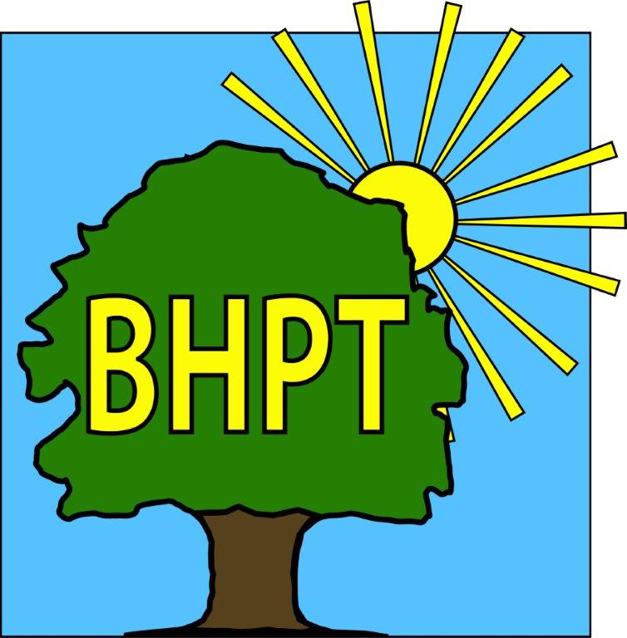
BHPT Newsletter
Jan 2023

Wishing all of the Round & About readers a Happy New Year.
It was lovely to see so many of you at the Lions Christmas Fayre in December. We made an impressive £377 for Burnham Care & Share and it was great to see so many happy faces.
In this edition we wanted to remind you about the local fitness provisions and what help is available with electricity & gas. We will also share with you our usual Care & Share update and information on our new initiatives, Hormones & Happiness and Job Club.

As always, we are continually updating our website to bring you the most up to date and useful information. Please register for updates and also to view our timetable of activities along with other information on useful local services. Our Facebook group also has details of forthcoming events, news and information. We also share posts on local groups so you wont miss out on local events.

If you require assistance, especially with food vouchers contact Lisa 07852 509075 or Rev Samson 07771728826 or you would like to speak to us please ring our office number on 01628 661441. Do leave a message if the answer machine is on, we might be on another call, but we will get back to you

Dawn Harries, Chief Officer and the staff and Trustees of Burnham Health Promotion Trust

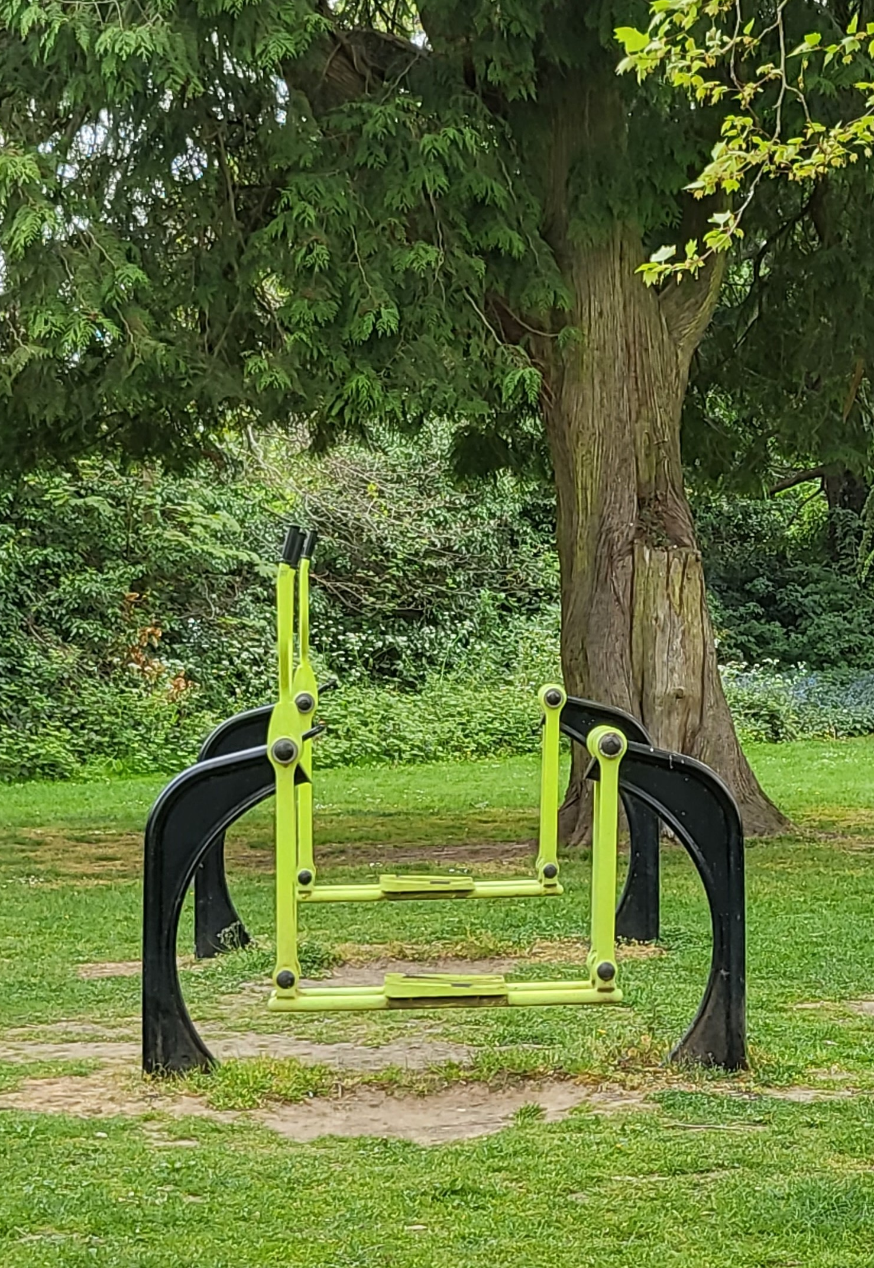
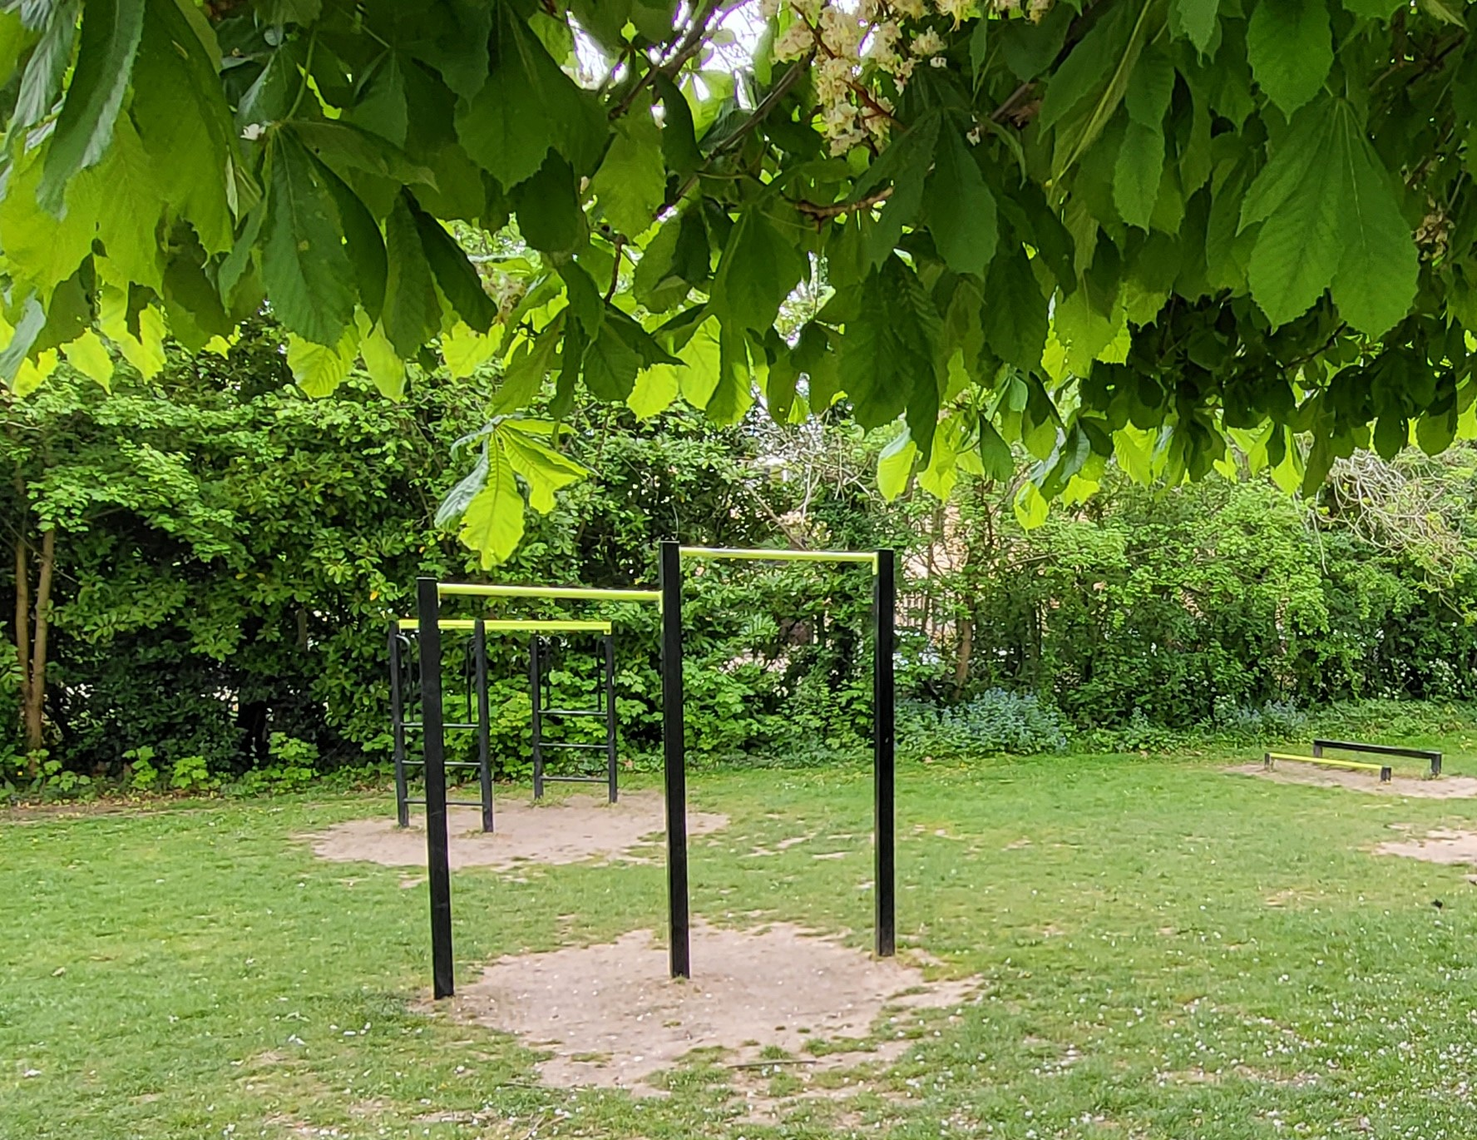
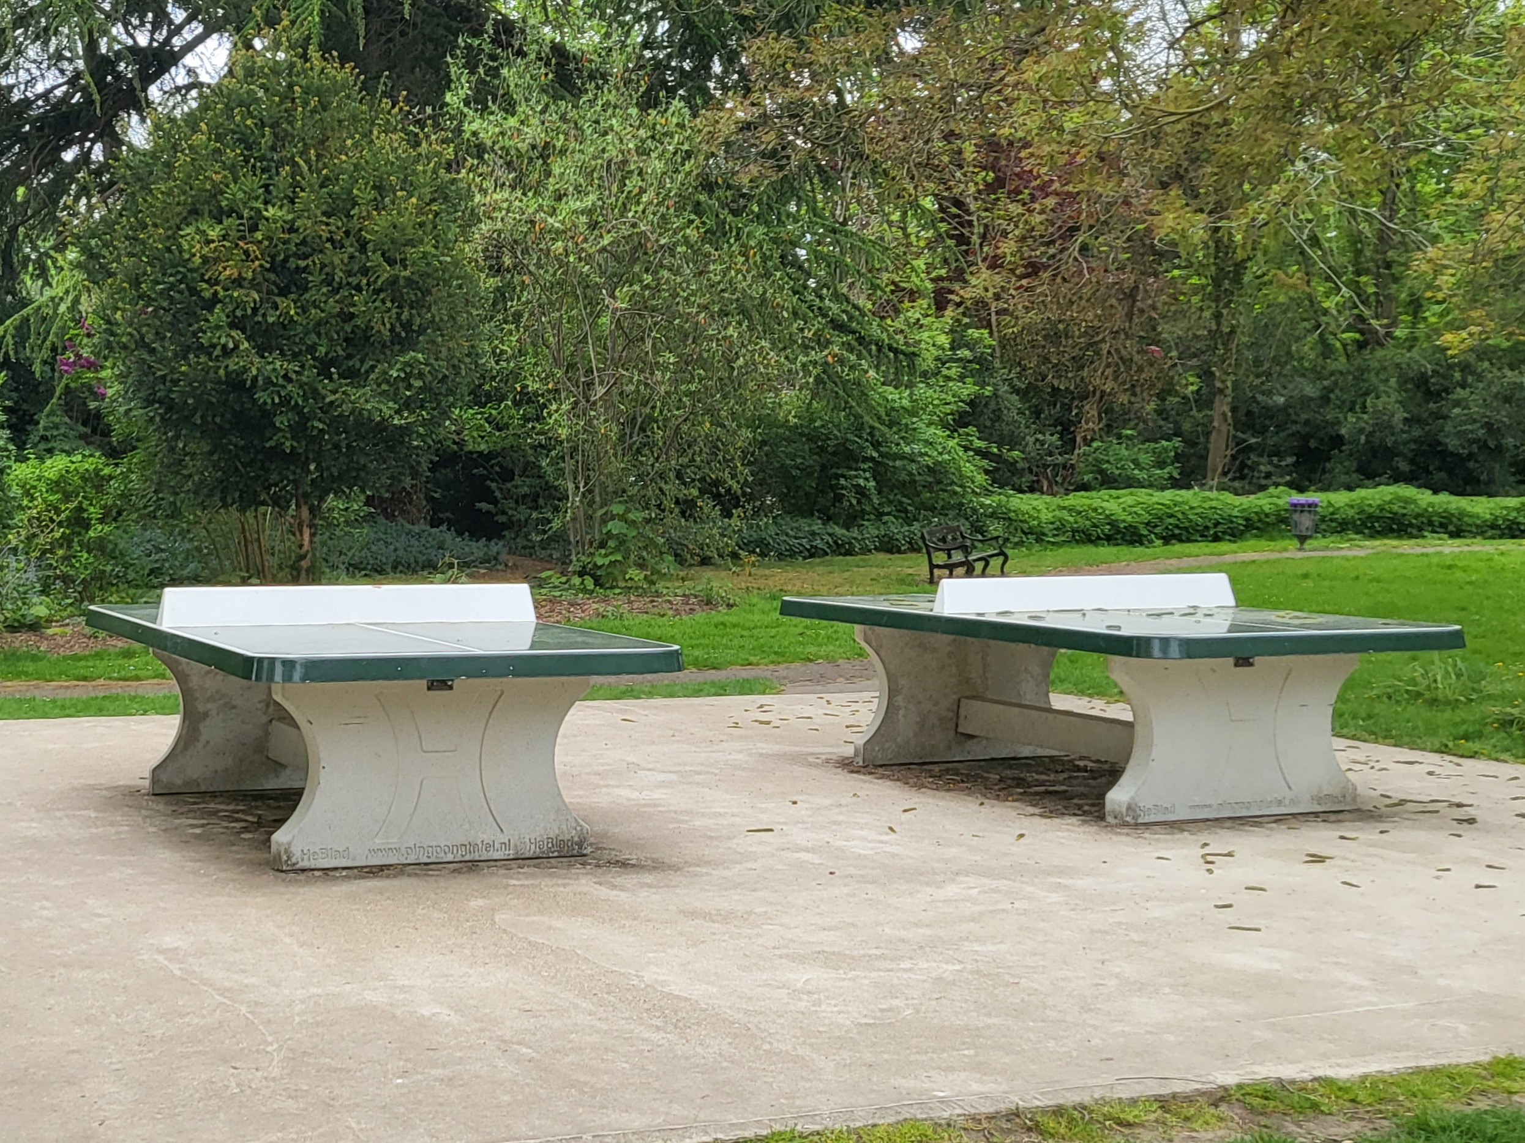
Get active for the New Year!
Are you thinking about getting fitter in 2023? Remember, sometimes it’s not just about losing them extra pounds, but improving your overall fitness or toning up. We are pleased to work with some great local providers who are eager to get us moving in a safe and caring environment.
- Seated Exercise with Donna is on Mondays. It is suitable for those over 60 and is on from 9.45am-10.45am at Burnham Methodist Church, it is £5 per session.
- Tai Chi with Colin Bond is also on Mondays at Burnham Park Hall, from 2-3pm. It is suitable for adults of all abilities and costs £5 per session of 4 for £15.
- Outdoor Gym group is on Tuesday 10.30am-11.30am at Burnham Park Green Gym. It’s free to attend and for adults of any age.
- Walking Football is on Wednesday, run by GLL in Burnham Park from 10am-11am. It’s £3 a session.
- Simply Walk has various walks on different day in the local area, for different abilities. See our timetable for more information.
- And for an informative walk around the park to get your steps up, check out the Tree Trail around Burnham Park (www.burnhamparish.gov.uk/treetrail).

For more information, such as contact details, on all of these initiatives please do look on our website for our timetable.

*SOON* Hormones & Happiness Ladies Well-being Day * SOON*
BHPT and The Wellbeing Boutique will be hosting a Wellbeing Afternoon for people starting, going through or finishing The Menopause. The event will take place on the afternoon of Sunday 29th January 2023 in the Dropmore Hall at Burnham Park Hall.
Attendees will be able to sign up to taster sessions of therapies such as massage, hand massage, foot care, standing yoga etc, all aimed at supporting through the menopause. We will also be on hand to talk about Hormones & Happiness, our new support group!
The first 40 people through the door will also receive a free goody bag. Taster sessions will be booked first come first served and no more than 2 per individual. We will also have local vendors selling skincare, holistic candles and foodie treats with samples for you to try. The hall bar will also be open to purchase drinks
Tickets will be £5 bought in advance or £8 on the door. Contact Lisa 07852 509075 or Gemma 07483 326525 for more information.

Energy Advice
This is a topic very much affecting many people right now and will certainly do in the coming months. We have put together many of the things you might need to know, from the government grants (for every household) to what other help may be available.
Visit our blog post at www.bhpt.org.uk/news/help-with-utilities if you do not have access to the internet and would like advice, please come in or phone us.

Job Club
BHPT are starting a Job Club in the New Year. If you are over 18 and looking for work or to change jobs, and would like some support with CV’s, applications, cover letters, interview tips and more, then this might be the group for you! It will be a free, weekly meeting at Burnham Library. By the time this edition comes to print we will have more information, so if you haven’t seen our advertising, please call or email Gemma on 07483 326525 gemma@bhpt.org.uk

Care & Share
We have had an incredible Christmas at Care & Share with so many donations of food, gifts and money towards our cause. From regular the Tesco deliveries, Street Association collections, from individuals donating money or food bags to local companies supplying blankets, socks, hats and toys as well as food! Also the support from other groups such as the Burnham Beeches Rotary Club, The Hitcham Trust, Burnham Grammar School and many more has been simply amazing.
Thank you to everyone who has supported in whichever way, you are all incredible. You have made our clients Christmas just a little bit more special!

Lastly thank you to our totally amazing volunteers, without whom we would not be able to run. Your kindness and support is most gratefully received, and we thank you from our hearts.

Wishing all our clients and supporters a Happy New Year 2023!
Lisa-BHPT, Rev Samson-St Peter’s Church.
our contact information
Burnham Health Promotion Trust, First Floor, Burnham Park Hall, Windsor Lane, Burnham, Bucks, SL1 7HR
01628 661441 - info@bhpt.org.uk - www.bhpt.org.uk

