Welcome to the latest
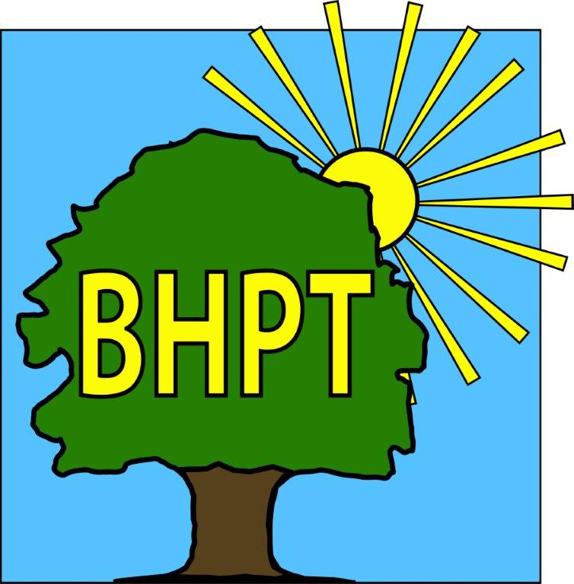
BHPT Newsletter
January 2022

Hello and wishing all of the Round & About readers a Happy New Year!
The BHPT staff are working from home but are available on the phone during office hours. All calls to the office divert to the work mobile, so if you have any queries please do get in touch.
If you require assistance, especially with food vouchers contact Lisa (07852 509075) or Rev Samson (07771728826), or you would like to speak to us for our services, please ring our office number on 01628 661441. Do leave a message if the answer machine kicks in, we might be on another call or busy, but we will get back to you.
In this edition we are sharing more Care & Share thanks, how we got on at the Lions Christmas Fayre and some fitness options for the new year. Along with The Well @ Lent Rise, we still continue to have our Citizens Advice appointments available in Burnham, please see the poster for how to contact them.
We have a website with lots of information and useful local services on. You can register on the website for updates and also view our timetable there. Do also check out our Facebook group for up to date information, news and details of upcoming events.
As ever, if you are concerned about a neighbour, relative or even yourself, take a look at our website or call us, to see what help is available in the local area. Please remember, pick up the phone if you require assistance or you want to talk. Stay safe everyone.

Dawn Harries, Chief Officer and the staff and Trustees of Burnham Health Promotion Trust

Getting Fit
Start 2022 off with your health & fitness in mind! We are lucky in Burnham to have several great classes on every week, to help ease back in to exercise, start gently or try something new. Here are a few we would like to highlight:
- Donna’s Seated Exercise - Burnham Methodist Hall, Eastfield Road - £5 every Monday 9.45-10.45, all abilities welcome. For more information call Donna on 01753 674945.
- Tai Chi with Colin Bond - Burnham Park Hall - Every Monday 2.15-3.15 £5 each or 4 for £15, all abilities welcome. For more information call Colin on 01628 666298.
- Walking Football - Burnham Park (meet in the car park) every Wednesday, 10-11 £3, all abilities welcome. For further information call 01895 837334.
- Tea Dance - Has restarted at The Cherry Orchard Pavilion - every Monday 1.30-3.30 £10 for the first week then £5 thereafter. Learn ballroom, Latin American & sequence dance steps. For more information see www.areyoudancing.com/dance-event/582478
- And of course, there is the Green Gym in Burnham Park (by the library) for everyone to use.

Care & Share News
In December we had such a busy month. There were 117 vouchers, which meant we helped 323 people, of which 158 were children.
We experienced an amazing sense of community spirit in December. Burnham Care & Share manages to operate with cash and food donations from the community and volunteers who give their time. We would like to say a few thank you’s.
Thank you to Burnham's community choir, 'Sing4You' who Sang outside Tesco Taplow for Care & Share. £114.26p was raised on our behalf so thank you to everyone and to Petra, Tesco Community Champion who organised it for us.
Big thanks to Progress Software Ltd - Diane & Julie for the amazing gift donations you gave our clients, they were really grateful, also to Cindy & the team from Mieko UK! Thank you to CleanConscience for the lovely toiletries gift bags, the Teale's and Tracey Emery for your amazing donations, Jacala Cub pack @ 1st Burnham & Hitcham Scouts and the congregation of The Higher Heights Church.

Thank you to everyone who took the time to drop off donations at our various collection points in the village including: Kavita & the team at Budgens, David & Louise via May's Chocolate Shop, Emily Knight, David Wise & his wife and other anonymous generous donors. There are just too may to mention, but no matter how big or small it goes to Burnham people who need that extra bit of support.

Lastly of course thank you to our volunteers past and present, who without we could not run as effectively as we do.
Lisa Pope and Rev. Samson Kuponiyi


Carers Support
If you are caring for someone (a relative, neighbour or friend) and have recognised that you now fall in to the carer role, there is support and advice available. Caring is a tough responsibility and brings challenges and additional needs. Firstly, you can register with Carers Bucks or Slough Carers support to have access to a wealth of knowledge on things such as respite, benefits and handy services. Make sure your Dr’s surgery know that you are a carer, you can let them know by filling out a form (available at reception) and then (if you are registered at Burnham Health Centre) your details will be passed on to us and we will contact you to let you know about our services, specifically, our Carers Support Group.
Carers Bucks - https://carersbucks.org - 0300 7772722 Slough Carers Support - https://sloughcarerssupport.co.uk - 01753 303428

Burnham Christmas Fayre
Well what an evening it was for the village! BHPT had a stall raising money for the Burnham Care & Share. We had a bottle & gift tombola and a children’s book lucky dip. We were sold out in record time and had so much fun seeing everyone, watching people win prizes and embracing the festive spirit. It was cold, but was a really great turn out, thanks to everyone who visited us that night - together with a generous donation from one of our volunteers, from the proceeds of selling her handmade decorations, we raised £347 for the Burnham Care & Share! All of the money goes directly to help families & individuals in the local community and is greatly appreciated.
Well done to all of the community groups and individuals for another successful Burnham event!

our contact information
Burnham Health Promotion Trust, Burnham Health Centre, Minniecroft Road, Burnham, Bucks, SL1 7DE
01628 661441 - info@bhpt.org.uk - www.bhpt.org.uk

