Welcome to the latest
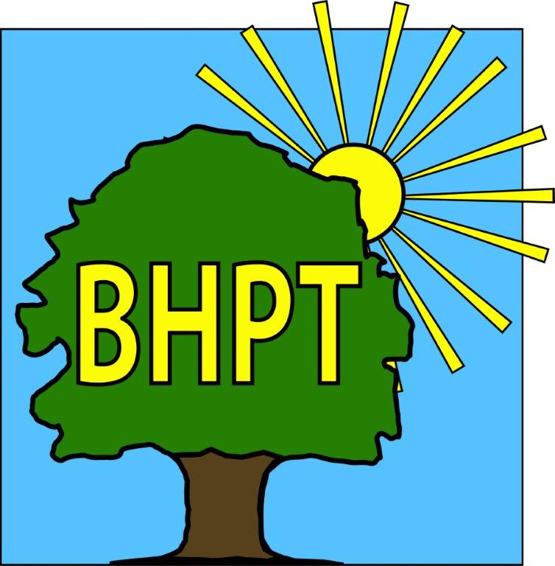
BHPT Newsletter
Apr / May 2022

Hello to our readers! The BHPT staff are in the office and ready to help with your enquires. We have a few updates for you today.

As always, we are continually updating our website to bring you the most up to date and useful information. Please register for updates and also to view our timetable of activities along with other information on useful local services. Our Facebook group also has details of forthcoming events, news and information. We also share posts on local groups so you wont miss out on local events.

If you require assistance, especially with food vouchers contact Lisa (07852 509075) or Rev Samson (07771728826) or you would like to speak to us please ring our office number on 01628 661441. Do leave a message if the answer machine is on, we might be on another call, but we will get back to you

Dawn Harries, Chief Officer and the staff and Trustees of Burnham Health Promotion Trust

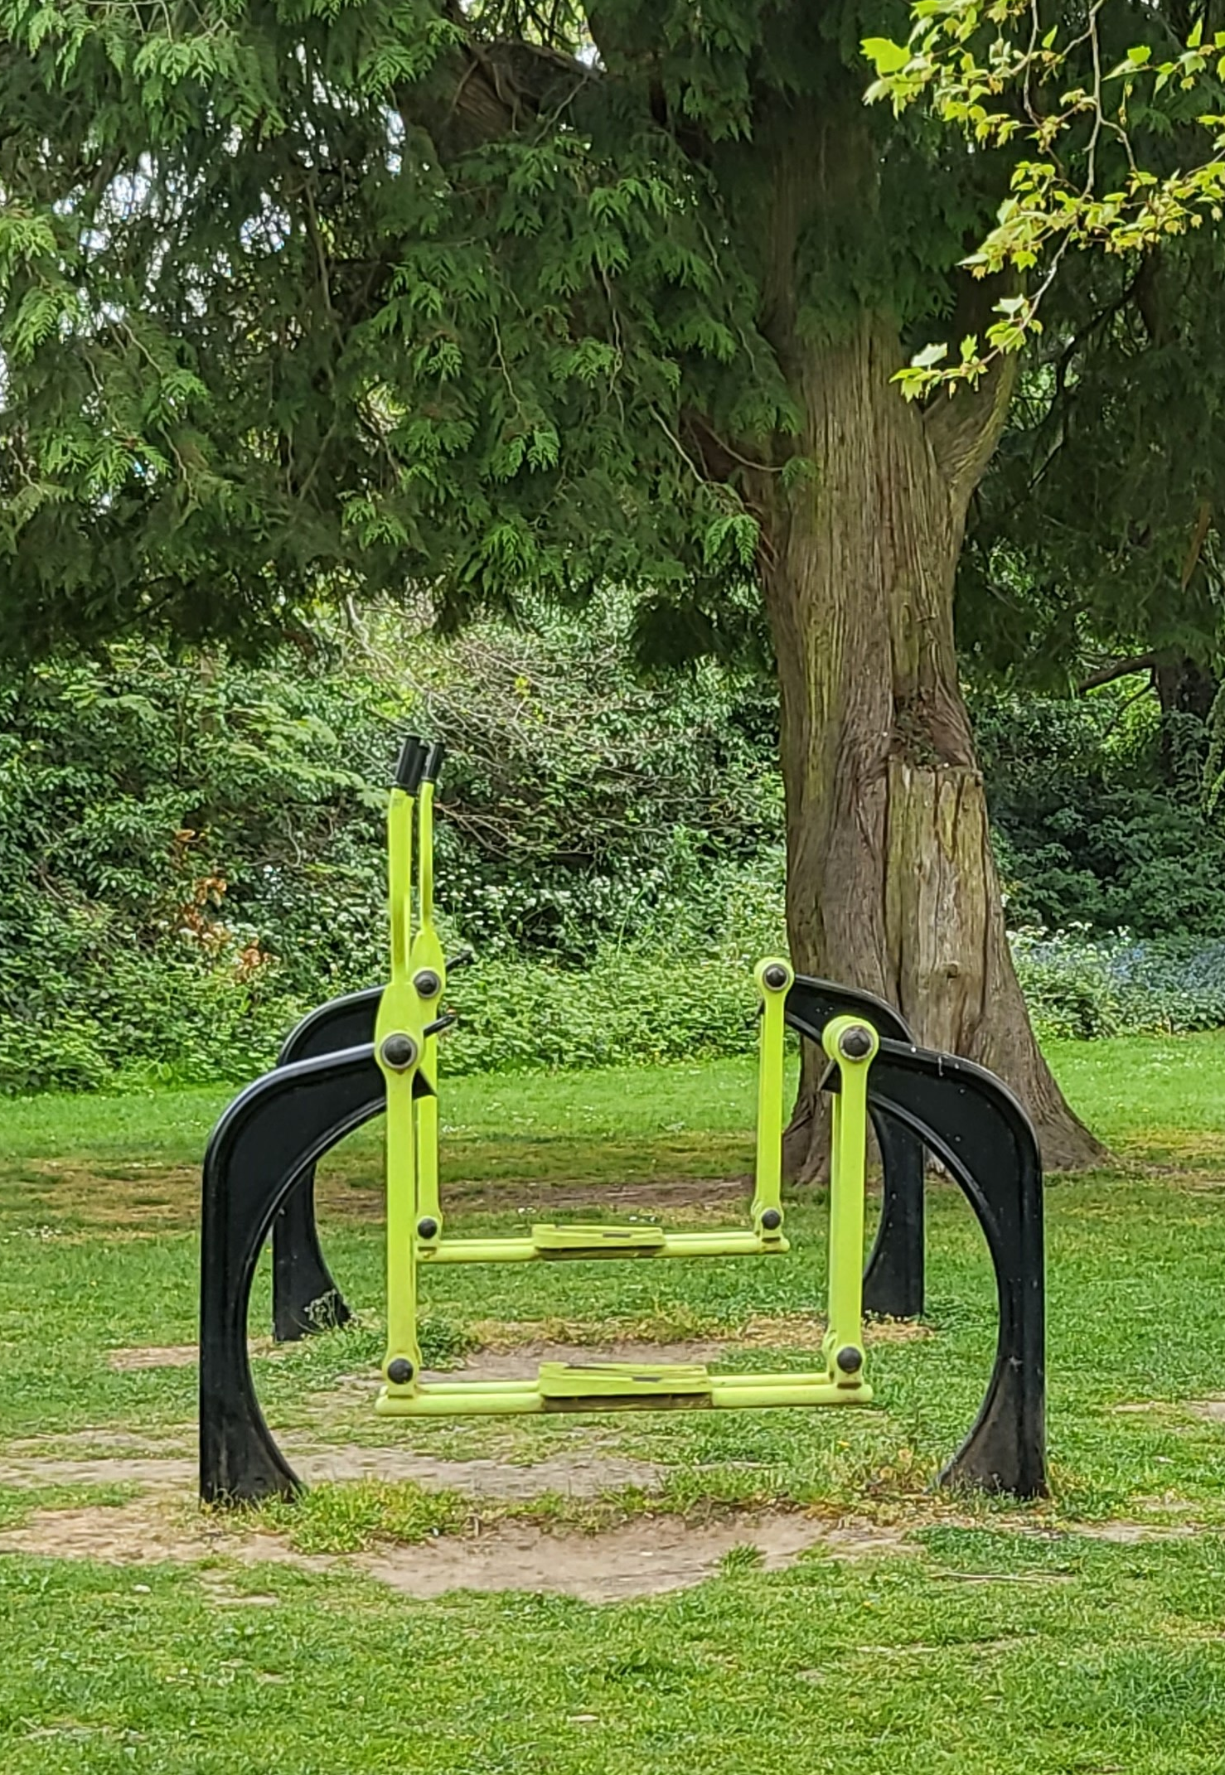
Burnhams Green Gym
In Burnham Park there is a green gym with many different exercise machines available. It is all weather, free to use and there is a group on Tuesdays from 10.30 - 11.30.
Adjacent to the Green Gym there are also permanent table tennis tables. For a £5 refundable deposit you can hire some table tennis bats and a ball to use while you are in the park (you can also leave your smartphone as a deposit if you like). These are available from Burnham Park Hall or Burnham Library, when they are open.
These great facilities are a great way to get fit and have fun at the same time.
They are suitable for all ages.
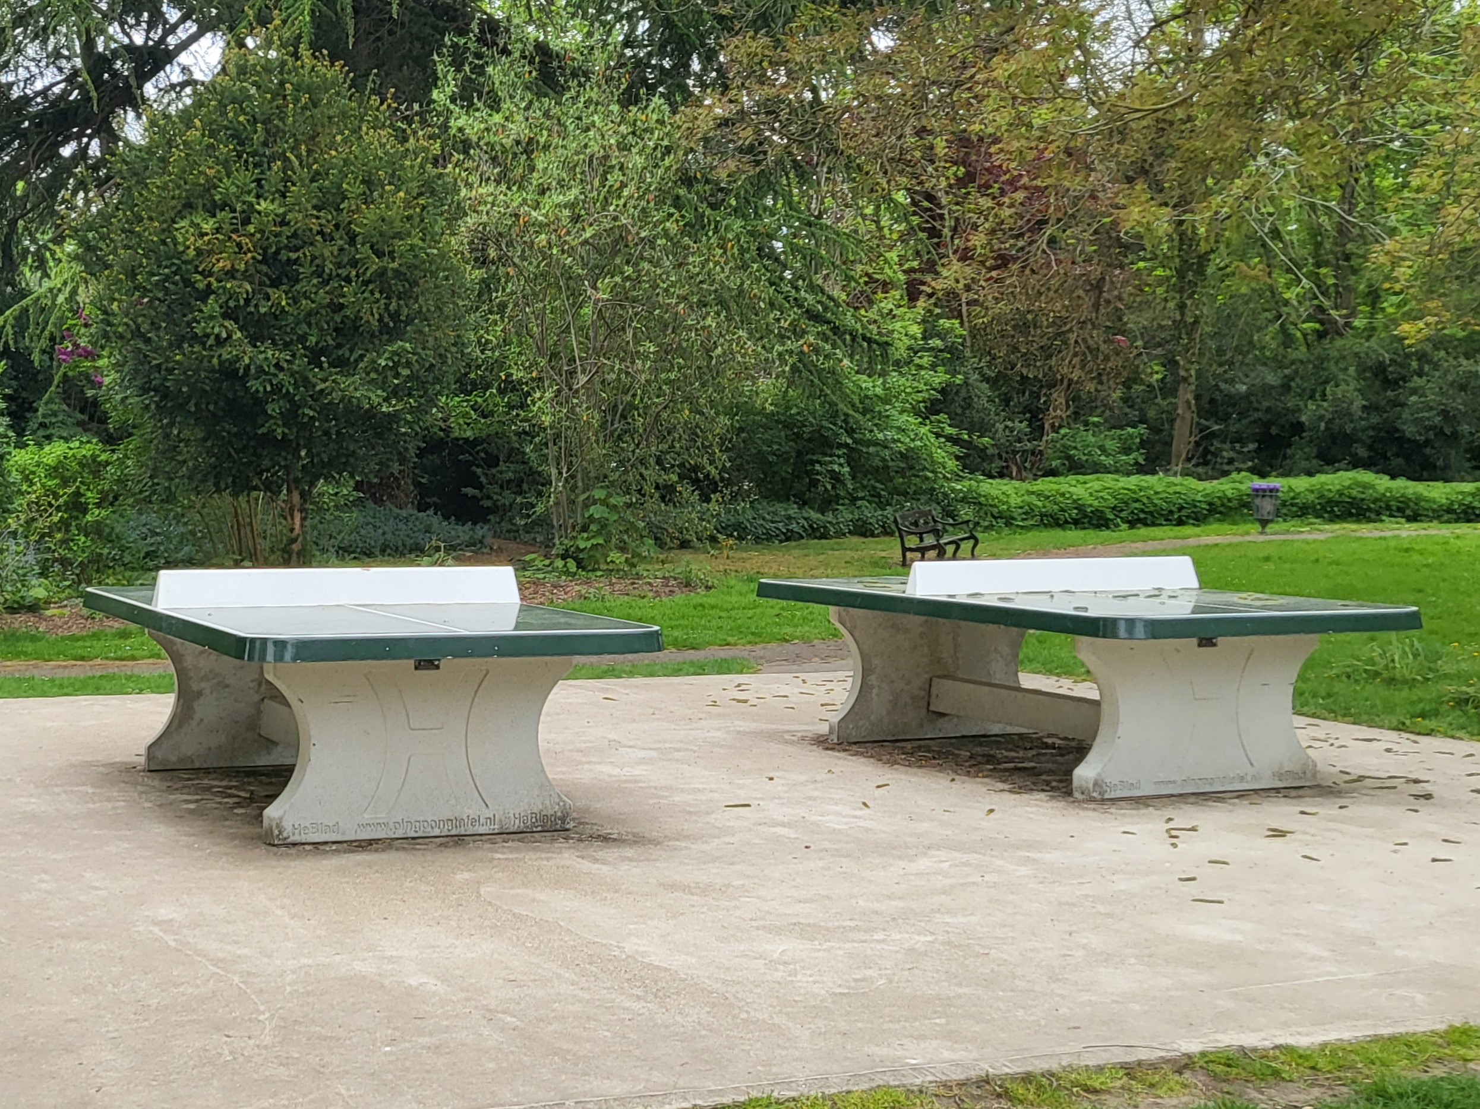
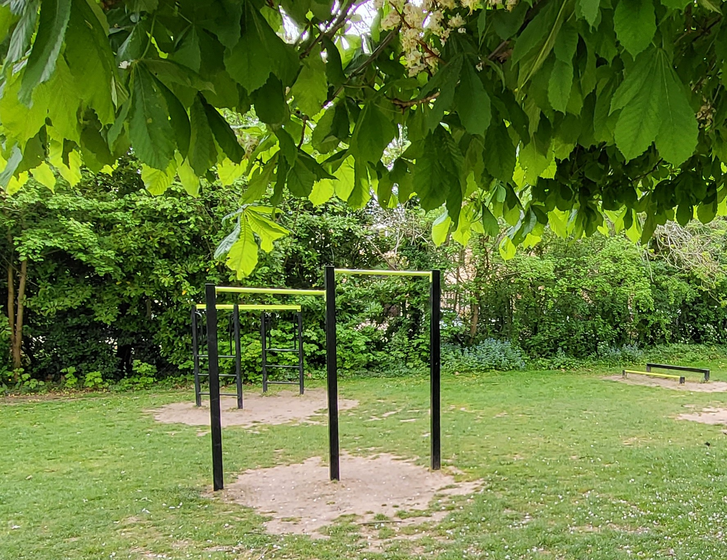

Donkey Derby
We will be at the Donkey Derby this weekend, supporting our friends Burnham Beeches Rotary Club. Please come and visit our Tombola and Craft Stalls.

BHPT @ The Burnham Village Fete
BHPT will be attending the Burnham Village Fete on Saturday 9Th July. We will be having another Bottle & Gift Tombola for Care & Share so will be collecting unopened bottles of anything and unwanted new toiletries.
We will also be having another craft stall and promoting the benefits of participating in some form of crafty activity on mental health and wellbeing. This is a great opportunity to have a sort out and donate your unused, unwanted craft materials or ready made crafts to raise funds for the local community. Have a look on our Facebook page for pictures from this weekend’s Donkey Derby to give you an idea of what we are collecting.
If you do have anything you wish to donate, give us a call or you can drop it to Care & Share in Burnham Park Hall or at the BHPT office @ Burnham Health Centre. So, if you are having a clear out, think of us. We are also entering the Eco Float Parade! We hope to see lots of other Eco Floats on the day.

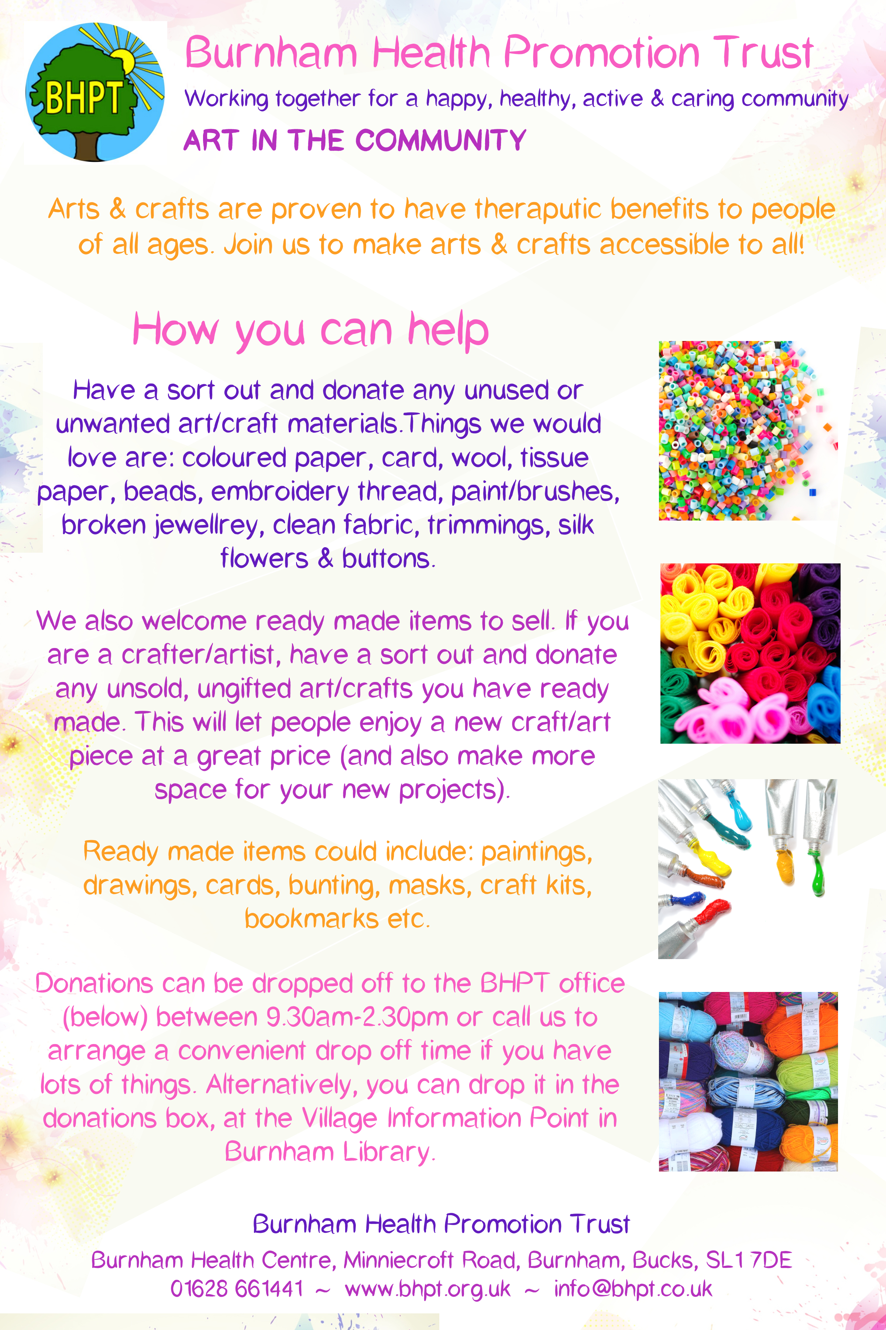
Care & Share
In April Care & Share supported 175 people, 85 of which were children. We are always grateful for all donations and thank all who give for their generosity. If you would like to make a monetary donation to Care and Share, to buy food and help people in fuel poverty please follow the link to our website here www.bhpt.org.uk if you are a taxpayer, we can claim gift aid on any donation you make.
We wanted to say a big thank you to the Higher Heights Church UK, who collected a massive donation during their Easter Service, St Peter's School children, families & staff for the amazing number of Easter Eggs donated, Cindy & colleagues at Meiko Service Support Admin Dept, Slough for a wonderful donation of Easter Eggs, treats and store cupboard food and all the individuals who dropped off Easter Eggs to our collection points. All our clients received a bag full of Easter treats, including Easter crafts & soft toys for the children.
Thank you to Tesco Taplow & Burnham, for their continued support with donations.
If you are considering donating, we welcome any of the following: tinned meat, tinned veg, tinned tomatoes, baked beans/spaghetti hoops, soup, tinned or packet, pasta, rice, tinned fruit, tinned fish, tinned/packet puddings, tea, coffee, sugar, UHT milk, squash, jam/spreads, wrapped biscuits & cakes, toilet roll, cleaning spray, bleach, washing up liquid, personal toiletries, nappies, wipes and bath products.
Any donations are welcome, no matter how small, please check that they are in date as we are not allowed to issue out of date food items.
Drop off locations are Burnham Park Hall, Burnham Village Information Point (inside the Library), Cornerstone @ St Peters Church & The Old Five Bells Pub.
If you need assistance, contact Lisa (07852 509075) or Rev Samson from St Peters Church (07771728826)
Lastly of course thank you to our volunteers and supporters past and present, without whom we could not run as effectively as we do. Thank you to everybody who has donated since our last article, there are too many to mention, but no matter how big or small it goes to Burnham people who need that extra bit of support.

Lisa Pope and Rev. Samson Kuponiyi

our contact information
Burnham Health Promotion Trust, Burnham Health Centre, Minniecroft Road, Burnham, Bucks, SL1 7DE
01628 661441 - info@bhpt.org.uk - www.bhpt.org.uk

