Welcome to the latest
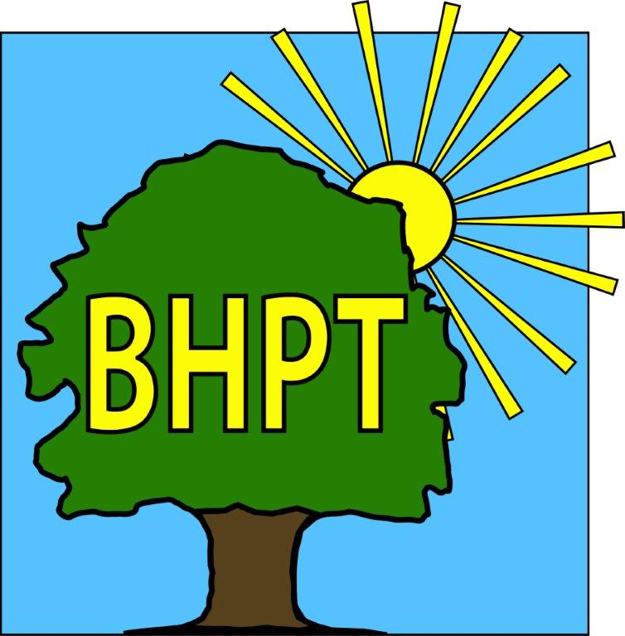
BHPT Newsletter
Jul / Aug 2022

Hello Everyone,
We would like to thank everybody for stopping by to say hello, donate and contribute to our stalls at the Donkey Derby & the Summer Fete this weekend. It has been great to see and talk to so many of you. Between the 2 events the community raised just over £700 that will go back to help the community, through Burnham Care & Share and our other community initiatives. We also entered the Eco Float Parade. There were so many great, creative entries and we came 3rd with our Queens Birthday Cake float!

As always, we are continually updating our website to bring you the most up to date and useful information. Please register for updates and also to view our timetable of activities along with other information on useful local services. Our Facebook group also has details of forthcoming events, news and information. We also share posts on local groups so you wont miss out on local events.

If you require assistance, especially with food vouchers contact Lisa (07852 509075) or Rev Samson (07771728826) or you would like to speak to us please ring our office number on 01628 661441. Do leave a message if the answer machine is on, we might be on another call, but we will get back to you

Look after yourselves and each other.
Dawn Harries and the staff & Trustees of Burnham Health Promotion Trust

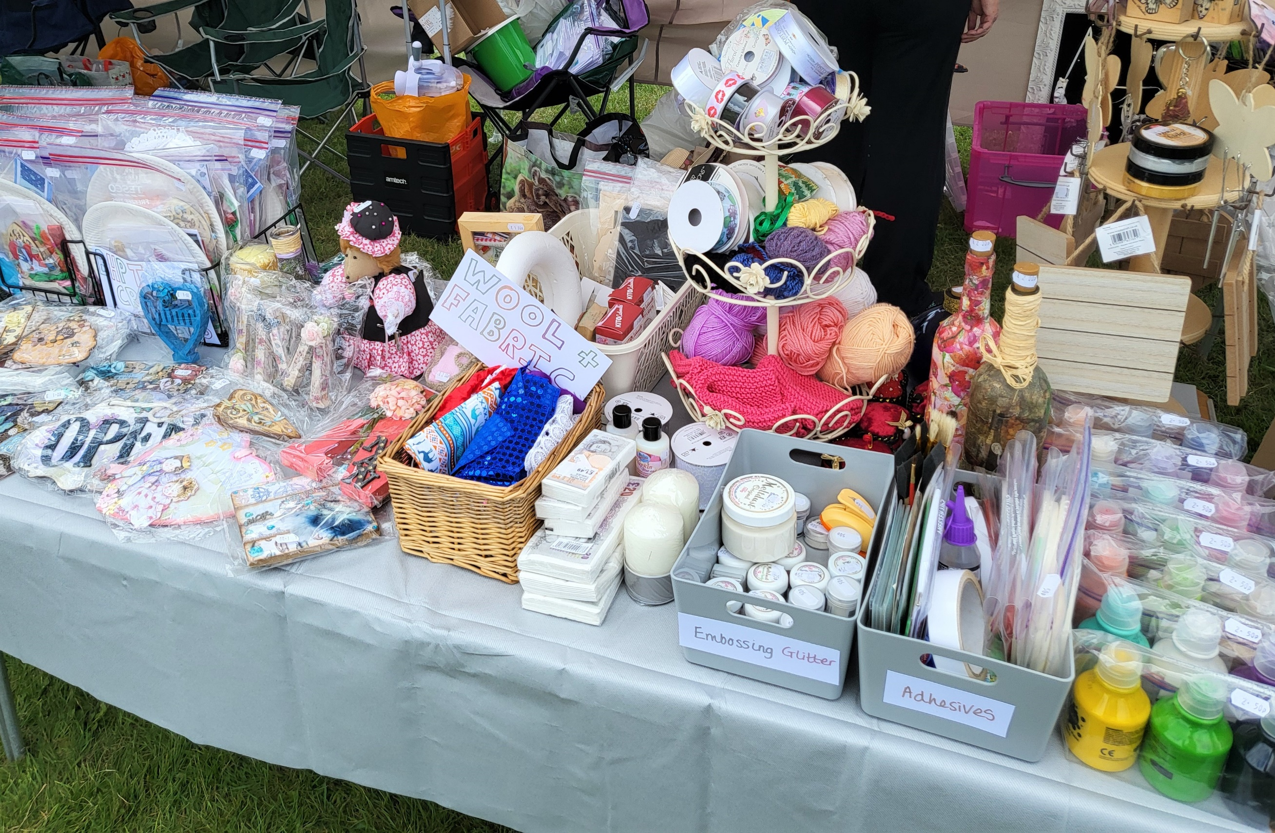
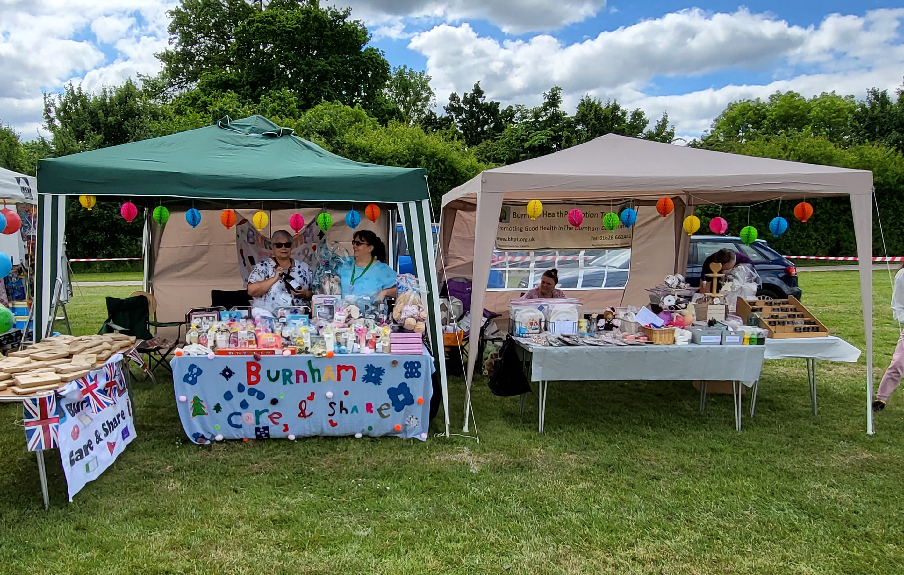

Simply Walk 20th Anniversary
Wednesday the 22nd June saw the 20th Anniversary of the set up of Burnham Simply Walk.
BHPT have been involved with this project from the start and continue to support the group as and when we are needed. We provided the walkers with refreshments and a lovely anniversary cake for the occasion and had on display photos of previous walks and events Simply Walk attended throughout those 20 years. If you would like to participate in future walks (walks are of varied levels, for all abilities and on different days of the week), please call BHPT on 01628-661441 for more information.

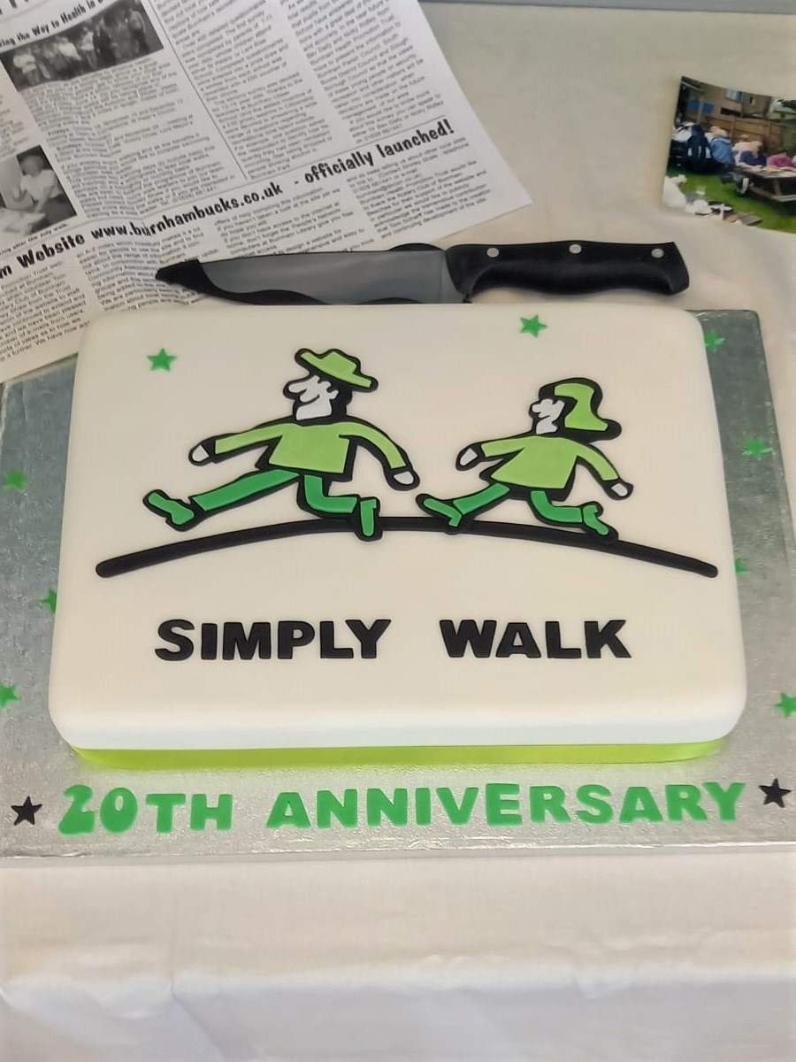
For more information, please contact Sue on 07774 642534, Linda on 07962 255743 or the BHPT office.

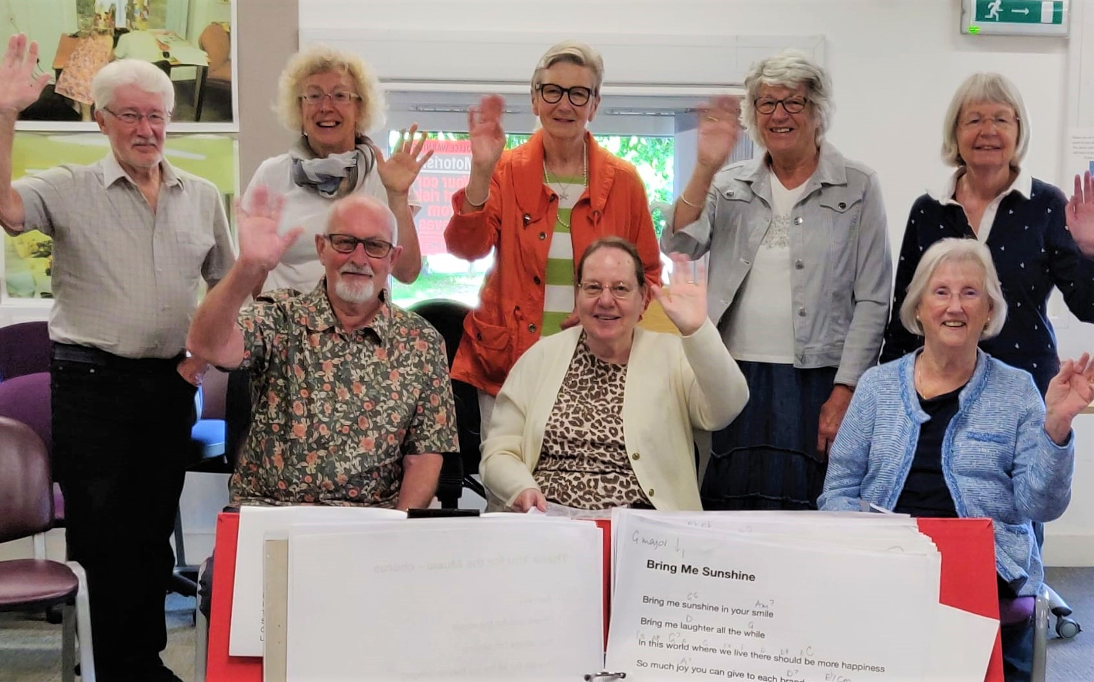
Singing For Your Memory
Singing for your memory has been back for a few sessions now with some new music. It’s a free group for people with early onset dementia/Alzheimers and memory loss and their carers. It is a friendly, inclusive group who gather to sing for pleasure. No experience is necessary. It meets twice a month on the 1st and 3rd Tuesday at Burnham Library from 11am-12noon.
Singing can unlock special connections to the past and reawaken memories. Did you see the article on the Maidenhead Advertiser last week? What a lovely write up. If you missed it, check it out online.

Left:
Care & Share win 3rd prize in the Eco Float Parade

Right:
Date Night with a book for Donkey Derby, raising money for Care & Share
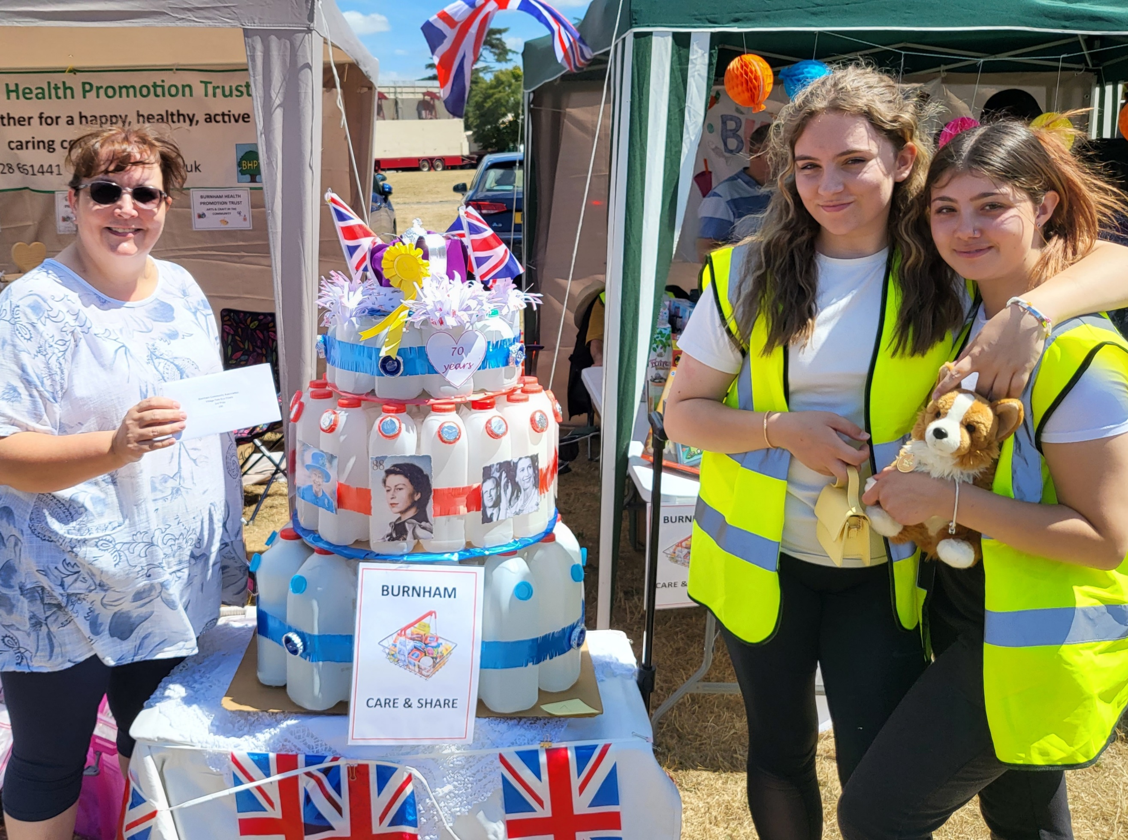
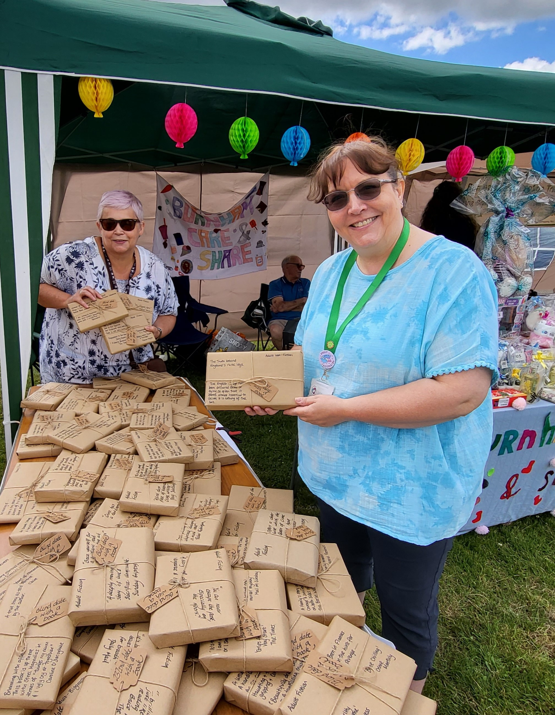
Care & Share
Care & Share has seen a steady increase in clients attending our twice weekly sessions. Some new clients as well as some older clients still in need of support. Since the last Round & About, we have supported a total of 493 people of which 258 were children and 235 were adults (May & June combined)
We always welcome donations of food and personal care/household items. Donations can be dropped off at Burnham Park Hall reception, Burnham Library, Cornerstone St Peter's Church, and The Old Five Bells Pub (all subject to their usual opening times).

If you would like to donate items but are unsure of what to purchase, you can look at our Facebook page for the pinned post of food bag items, or feel free to contact BHPT on 01628-661441 for suggestions. We also welcome financial donations via the link on our website www.bhpt.org.uk.
Thank you of course to our volunteers and supporters past and present, without whom we could not run as effectively as we do. Thank you to everybody who has donated since our last article, there are too many to mention, but no matter how big or small it goes to Burnham people who need that extra bit of support.

Lisa & Rev. Samson

Burnham Village Information Point

Burnham Library is home to the Information Point.
You will find it on the right hand side, at the back of the library. Here you can find things like:
- Local sports activities, clubs
- Where to find help & advice
- A phone available if you need to contact the council
- Vast array of leaflets for things to do
- Care & Share donation point, glasses & hearing aid recycling
- Back issues of Round & About

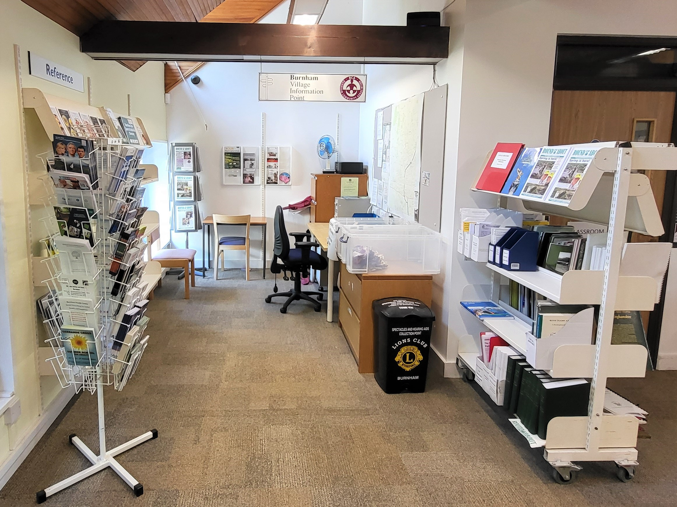
our contact information
Burnham Health Promotion Trust, Burnham Health Centre, Minniecroft Road, Burnham, Bucks, SL1 7DE
01628 661441 - info@bhpt.org.uk - www.bhpt.org.uk

