Welcome to the latest

BHPT Newsletter
Feb / March 2022

Hello and wishing all of our readers a Happy Spring! The BHPT staff are back in the office and ready to help with your enquires. It has been great to start seeing everyone again when you are in the Health Centre.
We wanted to share a couple of updates with you. Firstly, we were very sad to hear about the death of our past colleague Marisa Di Bartolomeo, who passed away on Feb 14th. Our thoughts are with her family and friends at this very sad time.
Care & Share will be once again, supporting our friends the Burnham Beeches Rotary Club at their Donkey Derby, on Sat May 28th. We will be holding another popular Gift, Toiletry & Bottle Tombola. If you have any unopened items you would like to donate, please drop them off at Burnham Park Hall or to BHPT at Burnham Health Centre. All profits go directly to Care & Share.
If you require assistance, especially with food vouchers contact Lisa (07852 509075) or Rev Samson (07771728826), or you would like to speak to us for our services, please ring our office number on 01628 661441. Do leave a message if the answer machine kicks in, we might be on another call or busy, but we will get back to you
Dawn Harries, Chief Officer and the staff and Trustees of Burnham Health Promotion Trust



Carers Support
We have mentioned this before, but it is very important. If you are caring for someone (a relative, neighbour or friend) and have recognised that you now fall in to the carer role, there is support and advice available. Caring is a tough responsibility and brings challenges and additional needs.
Firstly, you can register with Carers Bucks or Slough Carers support to have access to a wealth of knowledge on things such as respite, benefits and handy services.
You also might be eligible for extra financial support. See www.entitledto.com and www.gov.uk
Then make sure your Dr’s surgery know that you are a carer, you can let them know by filling out a form (available at reception) and then (if you are registered at Burnham Health Centre) your details will be passed on to us and we will contact you to let you know about our services, specifically, our Carers Support Group. Caring can be a lonely experience, but you are not alone.
Carers Bucks - https://carersbucks.org - 0300 7772722
Slough Carers Support - https://sloughcarerssupport.co.uk - 01753 303428

Care & Share would once again like to give our clients Easter Eggs this April.
If you would like to donate one, you can drop off at either:
Burnham Park Hall
Burnham Library
St Peter's Church.
Although we have other collection points, these 3 are the easiest to collect from for these particular items.
We currently have a number of dairy free clients and also a Soya free client, so would be grateful to receive some of these particularly for 2 of them, who are children.

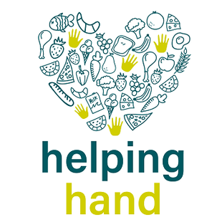
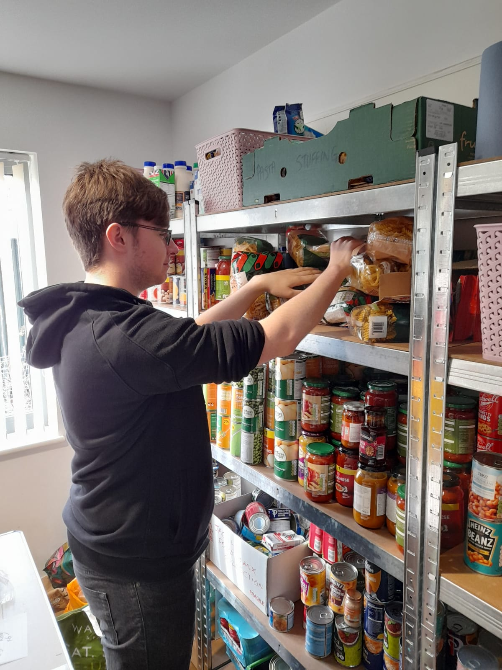
Huge thanks to Petra the Community Champion at Tesco, Taplow for arranging this trolley load of food and household items for Care & Share today. It came at just the right time!
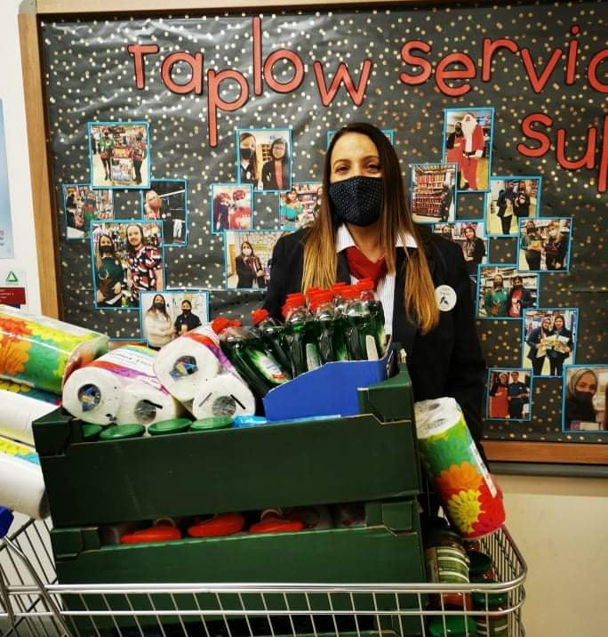
We are delighted to announce that Care & Share has been awarded a grant from Helping Hands @ Buckinghamshire County Council (courtesy of the Dept of Work & Pensions Household Support Grant).
This means we will be able to continue to support our current and future Care & Share clients over the next few months, when food & fuel prices are set to soar!
Helping Hands have been very supportive of our community foodbank during the pandemic and we look forward to working in collaboration for the foreseeable future. If you would like to see how Helping Hand can support people in the community visit their website:
https://www.buckinghamshire.gov.uk/housing-and-benefits/support-with-food-bills-and-finances/
Lastly of course thank you to our volunteers past and present, who without we could not run as effectively as we do. Thank you to everybody who has donated since our last article, there are just too may to mention, but no matter how big or small it goes to Burnham people who need that extra bit of support.

If you are considering donating but are unsure what we need, you can find a list on our website. The things we tend to run out of the most are UHT milk, tinned meat, tinned veg & tinned fruit and washing up liquid.
If you need assistance contact Lisa (07852 509075) or Rev Samson (07771728826)

Lisa Pope and Rev. Samson Kuponiyi

our contact information
Burnham Health Promotion Trust, Burnham Health Centre, Minniecroft Road, Burnham, Bucks, SL1 7DE
01628 661441 - info@bhpt.org.uk - www.bhpt.org.uk

